IN/OFF CAMPUS ACTIVITY SHCEDULING INFORMATION SYSTEM

A Thesis Presented to the Faculty of the
School of Information Technology and Engineering
St. Paul University Philippines,
Tuguegarao City, Cagayan

In Partial Fulfillment
of the Requirements for the Degree of
Bachelor of Science in Information Technology

By:
ROBERT A. SIMEON JR.
LOUISE ANTHONY S. BUGAYONG
JUNE 2026

APPROVAL SHEET
In partial fulfillment of the requirements for the degree BACHELOR OF SCIENCE IN INFORMATION TECHNOLOGY, MAJOR IN WEB AND MOBILE APPLICATION, this thesis titled, “IN/OFF CAMPUS ACTIVITY SCHEDULING INFORMATION SYSTEM,” has been prepared and submitted by ROBERT A. SIMEON JR. and LOUISE ANTHONY S. BUGAYONG, who are hereby recommended for Oral Examination.

RUCELJ D. PUGEDA, DIT

Adviser

FE S. MASIGAN, DME
Data Consultant

AELTHEO JOSHUA B. BALUBAL Language Editor

Approved by the Panel for Oral Examination with a grade of PASSED.

PANEL OF EXAMINERS

MARIFEL GRACE C. KUMMER, DIT
Chairperson

MARIA VISITACION N. GUMABAY, DIT
Member

CARLOS L. BABARAN JR., DIT SHEENA G. GUMARANG, DIT
Member Member

Accepted and approved in partial fulfillment of the requirements for the degree, BACHELOR OF SCIENCE IN INFORMATION TECHNOLOGY, MAJOR IN WEB AND MOBILE APPLICATION.

MARIFEL GRACE C. KUMMER, DIT
Dean, School of Information Technology and Engineering

ACKNOWLEDGEMENT
The researchers would like to express their deepest gratitude to all those who have contributed to the completion of this research. They especially wish to thank:
The School of Information Technology and Engineering, their department, for cultivating an innovative environment that inspired them to expand and strengthen their technical capabilities.
Dr. Marifel Grace C. Kummer, Dean of the School of Information Technology and Engineering, for her trust in their potential and for providing the opportunity to develop this project.
Dr. Rucelj D. Pugeda, their adviser, for his unwavering encouragement and expert guidance. His attentiveness, consistent monitoring of progress, and insightful feedback were instrumental in the refinement of this research.
The researchers further acknowledge the members of the panel Dr. Marifel Grace C. Kummer, Dr. Carlos Babaran Jr., Dr. Sheena G. Gumarang, and Dr. Maria Visitacion Gumabay for their time, effort, and constructive critiques during the review process.

The researchers thank their families and friends for their immense patience and support. From the initial proposal to the final implementation, their presence and encouragement provided the researchers with the necessary strength to persevere.
Finally, they offer thanks to the Almighty God for the spiritual strength and fortitude to overcome every challenge encountered during this journey.

TABLE OF CONTENTS
Contents Page
TITLE PAGE ............................................ i
APPROVAL SHEET ........................................ ii
ACKNOWLEDGEMENT ..................................... iii
DEDICATION ............................................ iv
TABLE OF CONTENTS ..................................... vi
LIST OF TABLES ...................................... viii
LIST OF FIGURES ....................................... x
ABSTRACT .............................................xiv

CHAPTER 1 THE PROBLEM AND REVIEW OF RELATED LITERATURE
Introduction................................. 1
Review of Related Literature ................ 4
Conceptual Framework ........................ 32
Paradigm of the Study ....................... 35
Statement of the Problem .................... 37
Significance of the Study ................... 38
Scope and Limitations of the Study .......... 40
Definition of Terms.......................... 42
CHAPTER 2 METHODOLOGY
Research Design ............................. 45
Participants of the Study ................... 54
Instrumentation ............................. 55
Data Gathering Procedure .................... 55
Data Analysis ............................... 57
CHAPTER 3 RESULTS AND DISCUSSION
Problems and Challenges Encountered by the departments in applying for In/Off Campus Activity Forms .............................. 58
The Developed In/Off Campus Activity Scheduling Information system ......................... 59
Extent of Compliance and the Developed System with ISO/IEC 25010 Software Quality Standard ............................................. 85
Recommended Enhancements for In/Off Campus Activity Scheduling Information System ............................................. 99
CHAPTER 4 SUMMARY OF FINDINGS, CONCLUSION, AND
RECOMMENDATIONS
Summary of Findings ......................... 102
Conclusion ................................. 104
Recommendations ............................ 104
REFERENCES | . . . . . . . . . . . . . . . . . . . . . | 106
Appendix A Interview Guide ............................ 114
Appendix B REC Certificate of Approval ................ 115
Appendix C Endorsement Letter ......................... 117
Appendix D Letter of Acceptance ....................... 118
Appendix E Questionnaire For IT Experts ............... 119
Appendix F Curriculum Vitae Certificate ............... 123
Appendix G Documentation .............................. 127

LIST OF TABLES
Table Title Page

1 User Roles in the Scrum Framework............ 47
2 User Stories for each User Role.............. 49
3 Hardware Requirements In/Off Campus Activity Scheduling Information System ............... 50
4 Software Requirements for In/Off Campus Activity Scheduling Information System ............... 51
5 Frequency and Distribution of the
Participants ................................ 54
6 Likert Scale the Developed System’s Compliance with
ISO 25010 Software Quality Standard ......... 57
7 Extent of Compliance of the Developed System with ISO/IEC 25010 Software Quality Standards in Terms of Functional Suitability ................... 85
8 Extent of Compliance of the Developed System with ISO/IEC 25010 Software Quality Standards in Terms of Performance Efficiency ................... 86
9 Extent of Compliance of the Developed System with ISO/IEC 25010 Software Quality Standards in Terms of Compatibility ............................ 88
10 Extent of Compliance of the Developed System with ISO/IEC 25010 Software Quality Standards in Terms of Usability ................................ 89
11 Extent of Compliance of the Developed System with ISO/IEC 25010 Software Quality Standards in Terms of Reliability .............................. 91
12 Extent of Compliance of the Developed System with ISO/IEC 25010 Software Quality Standards in Terms of Security ................................. 93
13 Extent of Compliance of the Developed System with ISO/IEC 25010 Software Quality Standards in Terms of Maintainability .......................... 95
14 Extent of Compliance of the Developed System with ISO/IEC 25010 Software Quality Standards in Terms of Portability .............................. 97
15 Summary on the IT Experts’ Evaluation on the Extent of Compliance of the Developed System with ISO 25010 Software Quality Standards ........ 98

LIST OF FIGURES
Figure Title Page

1 Conceptual Framework ....................... 32
2 Paradigm of the Study ....................... 35
3 Agile Scrum Development Model ............... 46
4 System Architecture ......................... 52
5 User Login Page ............................. 60
6 Admin Dashboard.............................. 61
7 Admin Dashboard Activities Tab .............. 62
8 Admin Dashboard Calendar Tab ................ 63
9 Admin Reports ............................... 64
10 Admin Dashboard Accounts Tab ................ 65
11 Admin Dashboard — Analytics Tab ............. 66
12 Admin Dashboard — Profile Tab ............... 67
13 Student Officer’s Dashboard ................. 68
14 Student Officer — Create Activity ........... 69
15 Student Officer — Profile ................... 70
16 Student Officer Notification Tab ............ 71
17 Adviser Dashboard ........................... 72
18 Adviser — Pending Approvals ................. 73
19 Adviser Profile ............................. 74
20 Dean Dashboard .............................. 75

21 Dean Pending Reviews ......................... 76
22 Dean Profile ................................. 77
23 PSG Council Adviser Dashboard ................ 78
24 Director Dashboard ........................... 79
25 Vice President for Academics Dashboard ....... 80
26 Adviser and Dean’s my approvals page ......... 81
27 Vice President for Academics, Director, and PSG Council Adviser’s my approvals page .......... 82

ABSTRACT
The management of in-campus and off-campus student activities has long relied on manual, paper-based processes. However, while this method provides basic documentation and monitoring, it is highly inefficient and prone to delays, scheduling conflicts, and miscommunication. In St. Paul University Philippines, the submission, review, approval, and monitoring of student activity requests continue to be processed manually by student officers, advisers, and administrative offices. To address these challenges, this study presents the In/Off-Campus Activity Scheduling Information System. It is a web-based platform designed to centralize and automate the scheduling, approval, and monitoring of student activities. The research used a descriptive developmental design. A descriptive approach was first used to identify the problems encountered in the existing activity management process, while a developmental approach guided by modern software development practices was applied to design and develop the system. The system was evaluated using the ISO/IEC 25010:2011 Systems and Software Quality Requirements and Evaluation standards. The evaluation focused on functional suitability, performance efficiency, compatibility, usability, reliability, security, maintainability, and portability. Results showed that the system meets the standards to a “great extent.” Overall, the developed system demonstrates strong potential as a reliable administrative tool. By automating activity scheduling, approval workflows, notifications, and conflict detection, it provides a more efficient, organized, and transparent alternative to the current manual process.

Keywords: Activity Scheduling System, Web-Based System, Workflow Automation, Information System, Real-Time Tracking

CHAPTER 1
THE PROBLEM AND REVIEW OF RELATED LITERATURE

Introduction
Educational institutions around the world face an ongoing challenge in managing an increasing number of academic and extracurricular activities. As more events are held, the amount of paperwork also increases, causing slowdowns in administrative work. This often results in delays in getting approvals, problems in communication, and inefficiencies that affect how smoothly institutions run. Depending on paper-based systems makes these problems worse, making it hard to track the progress of requests and leaving students, staff, and administrators frustrated. In addition, using too much paper goes against the sustainability goals that many institutions are trying to achieve (Rohini et al. 2024).
In response to these challenges, the adoption of automated systems has proven effective in improving operational efficiency, transparency, and decision-making across various sectors (Bregabiel and Santia, 2024). The shift toward digital solutions not only enhances institutional workflows but also promotes better interdepartmental cooperation and supports informed decision-making. With the complexity of administrative tasks in educational institutions continuing to rise, the integration of real-time tracking and improved communication systems has become increasingly imperative Hall et al. (2022).
At the national level, educational institutions in the Philippines experience similar challenges, particularly in managing the growing number of academic and extracurricular activities. The reliance on traditional paper forms for submitting, approving, and tracking activity requests is a source of inefficiency. This not only delays processes but also causes confusion among users, who often have little visibility into the status of their requests. The use of paper forms contradicts the increasing emphasis on environmental responsibility in educational settings, where institutions are being encouraged to embrace digital solutions to reduce their carbon footprint. The implementation of an automated system is therefore seen as an essential step to address these challenges and improve administrative workflows Bregabriel et al. (2024).
In the local context of St. Paul University Philippines, the increasing number of academic and extracurricular activities has placed considerable strain on the university's administrative processes, particularly within the Office of Student Affairs and various council offices. The current system of paper-based submissions for activity approvals has resulted in delays, miscommunications, and a lack of efficiency, frustrating both students and staff. Additionally, the university's commitment to sustainability is hindered by the continued use of paper forms. This project aims to address these issues by developing a user-friendly, web-based platform for submitting, approving, and monitoring activity forms, specifically streamlining the workflows of the Office of Student Affairs. The proposed system can reduce delays, improve communication, and provide real-time updates. By eliminating the need for physical paperwork, it also aligned with the university's sustainability goals.
This research focused on improving the manual request process by ensuring that the system was effective and that users were satisfied, while remaining compliant with ISO 25010 standards for software quality. The study also aimed to establish a reliable framework for evaluating system performance and ensuring adherence to global standards. It promoted transparency and accountability in the approval process and reduced paper-based workflows, supporting environmental sustainability.

Review of Related Literature
This area presents the review of related literature and studies that the researchers encountered during the conduct of their research.
University Activity Management System
Activity Management System plays a pivotal role in streamlining the operational efficiency of institutions by providing a structured method for managing activities. This centralized hub serves as the focal point for all activities from submission through to approval and resource allocation, simplifying the process for administrators and participants alike. The importance of such a system cannot be overstated given the significant benefits it provides to daily operations and long-term planning (Laudon et al., 2021).
Hariprasad et al. (2023) presented the College Club Activity Management System, which is a platform that helps manage student clubs, memberships, events, communication, and record-keeping. By making administration easier and giving students a simple platform to join extracurricular activities, the system brought all club functions together into one application instead of managing each club separately.
Building on this idea, Garcia et al. (2022) pointed out one of the most important features of activity management systems: a shared calendar that helps organize events and meetings while avoiding schedule conflicts. This feature makes it easier for students to join multiple events without worrying about overlapping schedules. Furthermore, the study noted that a shared scheduling system can be a useful tool for organizing activities across different departments and groups within a school.
In the same way, Lopez et al. (2022) stressed how important it is to have centralized and automated tools for managing student activities in schools. By solving problems like schedule conflicts and poor feedback tracking, the study showed how systems that bring everything together can improve coordination, communication, and overall efficiency in managing school activities.
Adding to this, Wijekoon (2021) studied a University Activity Management System that focused on using a school's own network to better organize activities. The system used machine learning to automate tasks like scheduling and tracking attendance, as well as predicting needs like student enrollment and staffing. These features show how modern technology can cut down on manual work and make school operations run more smoothly.
Moreover, Martinez et al. (2022) identified automated scheduling as a key feature of modern activity management systems. Their study explained that smart scheduling tools can handle the common problems that come with doing schedules by hand, since they automatically adjust when changes happen. This makes it easier to submit, approve, and organize activity requests while helping users handle busy schedules more efficiently.
Going further, Santos et al. (2022) highlighted the value of adding automated and predictive tools to activity management systems. These improvements are meant to make operations more efficient, reduce the amount of work for administrators, and give useful information that helps schools make better decisions.
Similarly, Hadiwiyanti et al. (2021) built a Campus Event Management Information System to solve repeated problems in managing campus events at a university in East Java. The system focused on collecting event data, organizing resources, and improving how events are carried out. Importantly, the study showed how bringing together scheduling, facility management, and event promotion into one platform can fix problems like low attendance and poor communication between people involved in the event.
Along the same lines, Reyes et al. (2022) highlighted that one useful feature of event management systems is event promotion, which helps spread information more widely and encourages more people to join. This same idea can be applied to activity management systems to make campus activities more visible and easier to access, which can lead to more students getting involved.
In addition, Mansouri et al. (2023) pointed out that modern campus event management systems depend a lot on good communication between event organizers and the people who manage school resources. This teamwork helps prevent scheduling conflicts and makes sure that the right facilities are available for different activities. The study also noted that this kind of coordination leads to better decisions about how to use resources for both on-campus and off-campus events.
In a related finding, Falasi et al. (2022) identified reporting tools as an important feature of campus event management systems, since they allow administrators to check how well events went and find areas that need improvement. The study explained that adding a similar reporting feature to activity management systems can help administrators make better plans for future campus activities based on real data.
Supporting this view, Kaabi et al. (2023) suggested that an online event organizer platform can be a good solution for managing both technical and non-technical events in schools. The system makes planning and coordination simpler by providing an online space where events can be registered, approved, and communicated about, reducing the need for manual work. Once approved by school authorities, students can upload event details like text and images, which are then shown on a shared dashboard for easy access.
Along the same lines, Hassan et al. (2024) stated that the main features of a web-based event management system match well with modern digital platforms made for organizing campus activities. The study explained that such systems solve common problems in event coordination by including features like event submission, approval, tracking, and real-time notifications for students. It also highlighted that decision-support tools help administrators quickly review event requests, especially those that do not follow standard rules, making the approval process more flexible and informed.
Furthermore, Nirupama et al. (2023) showed how the College Event Organizer, an online event management platform, can reduce administrative work and make it easier for students to join events. The system uses a simple and easy-to-use interface to bring event management together in one place and improve communication between administrators and students, while also automating processes and sending instant updates on event status and approvals.
In a related study, Mazrouei et al. (2023) explained that digital event management platforms show how technology can improve campus event coordination through better communication and higher student participation. The study pointed out that the main goal of such systems is to make event management smoother using a well-organized, web-based platform with built-in decision-making tools, all while making the overall campus experience better through the use of modern technology.
Consistent with these findings, Nuaimi et al. (2022) stressed that managing campus activities well — including events, attendance, and duty assignments — is very important for keeping school operations running efficiently. In response to these challenges, Rohini et al. (2024) created Campus Sync, a system with three main parts: Attendance Tracking, Event Coordination, and Duty Roster Management. This all-in-one approach not only improves how campus activities are organized but also helps different departments work together better by replacing paper-based tasks with a digital system.
Expanding on this, Kaabi et al. (2024) explained that putting different management tasks into one digital platform is a major advantage of modern campus management systems because it saves time and reduces the workload for administrators. The study noted that an event coordination module helps with smooth scheduling, room allocation, and event planning, while attendance tracking makes it easier to monitor students, and duty roster tools simplify the process of assigning and approving duties. Together, these features help campus activities run more effectively.
Notably, Johnson et al. (2024) confirmed that combining event, attendance, and duty management into one system is very helpful for improving how schools handle campus activities. Having everything in one place makes it easier for staff and students to stay informed and work together, which reduces the confusion that often comes with organizing events. The study also pointed out that a system that works across multiple platforms makes it more accessible and easier to use for everyone involved.
Shifting to the student's point of view, Yang et al. (2024) observed that students often struggle to find and join extracurricular and volunteer activities on campus because the process of searching for opportunities manually takes too much time. To solve this, they created a mobile platform that gathers information about available activities in one place, making it easy for students to find, compare, and sign up for events. The platform includes features like user login, push notifications, PDF summaries, and real-time data updates to keep everything secure and current.
Supporting this, Brown et al. (2024) explained that using digital platforms in schools has been shown to increase the number of students who take part in activities. The study found that a simple interface, good organization, and timely notifications make it easier to register for events while also reducing the workload for both students and organizers. It also noted that giving students PDF summaries of chosen activities helps them plan ahead and think about their involvement.
Relatedly, O'Connor et al. (2024) showed that mobile platforms built for event management can greatly increase student participation and volunteerism. By focusing on efficiency, easy access, and a design that puts users first, these systems serve as good examples for future web- and mobile-based tools. The study also emphasized that the success of such platforms proves how important technology is in making campus life better and supporting school administration.
Similarly, Rachel et al. (2022) developed an automated system to help reduce the amount of work that school staff have to do, giving them more time to focus on students' needs and growth. The system uses a mobile app to automatically handle tasks like tracking attendance, checking documents, and updating awards. By removing the need to do these routine tasks by hand, staff can spend more time on activities that directly help students, while also preventing problems like students missing important documents before exams.
Additionally, Williams et al. (2022) highlighted the importance of giving all parties students, parents, and administrators access through an automated system. For example, parents can keep track of their child's academic and extracurricular performance, while students can update their achievements and have them confirmed by their mentors. This feature keeps students, families, and school staff in regular contact, making sure that progress monitoring and feedback are always accurate and up to date.
In the same way, Taylor et al. (2022) showed that an automated campus management system can greatly reduce the burden on administrators while encouraging more engagement from the school community. By making key tasks like recording attendance and reporting progress easier, the system improves how the school runs while also making things clearer and more understandable for students and parents.
On a broader scale, Balu et al. (2021) pointed out that managing events in schools is getting more complicated as the number and size of activities keep growing. Old tools like spreadsheets and paper records are often not enough to handle the large amounts of data involved, making tasks like finding information and creating reports slow and difficult. To fix this, they proposed a Smart Event Management System that uses modern technology to make data management easier, automate reports, and improve overall efficiency.
Adding to this, Ivanov et al. (2021) explained that such a system is designed to make it simpler to manage different types of events, such as workshops, conferences, and other school activities. By automating tasks like entering data, tracking events, and creating reports, the system reduces the workload for staff, improves the accuracy of information, and speeds up decision-making. These capabilities are especially useful for both on-campus and off-campus activities where tracking things in real time is very important. Balu et al. (2021) further noted that using such automated systems is not only important for efficiency but also for making sure that event information is always easy to find.
In line with this, Lavania et al. (2023) developed a mobile app to improve event management in schools. Traditional methods like spreadsheets and manual tracking often cause problems and become hard to manage as the number of events grows. The proposed Online Event Management system solves this by letting administrators create, update, or cancel events from anywhere, while students can easily find event details and track their participation, greatly reducing the amount of work needed to manage events.
Furthermore, Kovalenko et al. (2023) highlighted the built-in features of the app that make things easier for students. Through the platform, students can register for events, track their attendance, and make payments — all in one place. This removes the need to use separate platforms for different tasks, while also helping students stay connected with their peers and keep up with upcoming activities. The system's data features also allow administrators to study participation trends and improve how future events are planned.
Together, Lavania et al. (2023) illustrated how digital event management can improve communication, lighten the load for administrators, and make the overall campus experience better. By automating routine tasks like event registration and payment handling, schools can create a more efficient and user-friendly way to manage events that saves time and encourages more students to get involved.
Finally, Thamrin and Andriani (2021) described how web-based systems not only allow students to submit requirements online but also let them track their progress, read announcements, and receive important updates. The platform also serves as a central place where all related documents can be accessed easily by both students and administrators, removing the need for students to visit the campus just to get updates. By moving administrative tasks online, the system improves overall efficiency and makes sure that important information is always available on time. Complementing this, Vanderbilt et al. (2021) presented a helpful solution to the difficulties that schools face in managing student-related processes. By automating tasks and keeping all data in one place, these systems make information easier to access and help administrative work get done more effectively, showing just how much technology can improve the way modern schools are managed. are carried out more efficiently and productively.
Student Involvement in Campus Activity Management System
Devi et al. (2021) established the Integrated Validation System (IVS) to optimize administrative procedures, improve service delivery, and increase decision-making inside these institutions. One of the important areas that can benefit from technological integration is student activity management, which encompasses numerous procedures such as project submissions, approvals, and monitoring. The extensive bureaucratic processes in these operations often delay decision-making and impair efficient student service. Thus, the proposed IVS intends to streamline these processes and improve overall student service performance.
Kuznetsova et al. (2021) further noted that the Integrated Verification System (IVS) makes the process of submitting and approving student activity proposals much easier. This system solves the common problem of long approval processes in activity management by automatically handling activity requests and checking submitted proposals through a single platform. By setting up such a system, students, teachers, and administrators can work together smoothly in managing campus activities, allowing for faster approval of activity requests and fewer mistakes that usually happen when activity forms are processed by hand. Overall, this kind of automation greatly improves how student activity administration is handled.
Building on this, Petrov et al. (2021) explained that the design of the IVS is especially important for developing activity management systems in universities and colleges. The system automates and brings together the management of student activities in one place, cutting down the time needed to process activity requests and making the information related to those requests more accurate. By supporting better decision-making in activity administration, it also makes the activity submission and approval process more reliable and efficient.
In line with this, Kuznetsova et al. (2021) demonstrated that setting up an integrated validation system can remove delays in processing activity requests and help campus activity management run more smoothly. This matches the goal of many schools to use technology that simplifies the handling of student activities, improves the experience of those involved, and supports smarter administrative decisions. The introduction of such technology is a big step toward making the management of student activities in higher education work better.
Furthermore, Rathaur (2024) developed the Student Result Processing System to fix the problems caused by manually handling student data. By using modern web tools like HTML, CSS, and JavaScript, the system provides a simpler way to store and track student-related data. This automated solution makes managing student records faster and easier, and it represents the growing movement toward automating school processes including activity management to improve the experience for both students and administrators.
Supporting this, Sosa (2024) pointed out that automated systems give students and administrators a simple and easy-to use interface for quickly accessing and managing important information. Students can safely view their records through personal profiles, offering a level of convenience and openness that was hard to achieve with manual methods. For administrators, the system provides a single platform for keeping student records, managing access, and tracking involvement in activities. This automated approach not only saves time but also supports accurate reporting and better decision-making in managing campus activities.
Furthermore, Ravanok (2024) highlighted that technology-driven systems are designed to improve how student data is tracked and managed in schools. The ability to generate statistics and analysis helps both students and administrators better understand trends in student participation and activity outcomes. The central management of student records also makes communication between different groups easier, making it simpler to share important information related to campus activities across the school. These features match the growing need for technology-based solutions in schools, especially those focused on making activity management more efficient and accessible.
Adding to this, Kumarp (2024) illustrated that such systems improve how student activities are managed, strengthen communication between those involved, and provide tools for making decisions based on real data. These improvements can be directly applied to building activity management systems that simplify administrative tasks in schools, making it easier to organize, track, and evaluate campus activities.
Transitioning to another development in campus management, Sel and Jom et al. (2023) explained that connecting Internet of Things (IoT) technology to school campus administration has become a growing area of research, with the goal of making the management of campus activities easier and improving how activity related systems work.
Complementing this, Arunk et al. (2024) highlighted how IoT is helping turn schools into smart campuses by allowing activity-related data to be collected and analyzed in real time. This change not only improves how campus activities are organized and carried out but also helps schools make better use of their resources, making activity management more responsive to the needs of students, staff, and administrators.

Moreover, Melro et al. (2024) emphasized that IoT can improve decision making in activity management by giving administrators detailed dashboards that show important information such as facility availability, space occupancy, and resource usage all of which are critical when planning and managing campus activities. These insights help administrators make smarter decisions about scheduling activities, assigning spaces, and handling the resources needed for events. The automation and real time tracking of campus activities also make it easier to respond quickly to changes, which is important for improving both the efficiency of activity management and the satisfaction of students taking part in those activities. Similarly, the use of IoT in smart campus systems could also be expanded to include tracking student participation and engagement in activities in real time.
However, as Sopyu et al. (2024) pointed out, moving toward smart campus activity management systems also comes with challenges, including the need for strong infrastructure, data security, and the ability to connect different activity-related systems together. While IoT offers many benefits in terms of making activity management more productive and user-friendly, putting these systems in place effectively requires careful planning and attention to both technical and organizational factors. Solving these challenges is key to making the most of IoT in managing campus activities, especially in areas like student engagement, activity tracking, and administrative efficiency.
Despite these challenges, the growing use of IoT technology in schools offers a great opportunity to improve how campus activities and resources are managed. As shown by Estoke et al. (2024), adding IoT to campus activity management can improve decision-making, make activity-related operations more efficient, and create more responsive environments for both students and staff. By embracing IoT, schools can better organize student activities, track participation, and make the best use of available resources, ultimately leading to a better and more engaging campus experience.
In a related development, event management is an innovative activity and event management program that helps schools organize and run campus activities more effectively. It simplifies the entire activity management process by making it easier to create activities, submit activity details, and send out invitations to participants. Teachers can quickly invite participants, collect feedback on activities, and share activity results, while students benefit from an easy registration system that removes the need for manual tasks. Students can sign up for activities, give feedback, and stay updated on activity outcomes, including the announcement of winners (Shoma et al., 2024).
Expanding on this, Welgriz et al. (2024) aimed to make campus activity management easier by providing a platform for designing activities, tracking student participation, and gathering feedback on campus events. The addition of decision-support tools to the system makes the approval process for activity requests simpler, allowing administrators to review, approve, and monitor both on- and off-campus activities. The web-based platform also makes it easier for students to register for activities, give feedback, and track activity outcomes, leading to more engagement and involvement in campus life.
Furthermore, event management system’s success in encouraging teamwork and active participation among those connected to the school serves as a good example for similar activity management systems. By following similar ideas and using a design that focuses on the user, managing campus activities becomes more efficient and the overall experience for students improves greatly. Real-time tracking of activity participation, feedback collection, and decision-support tools gives administrators useful information that leads to better management decisions and a more active campus environment (Soln et al., 2024).
In addition, the features of an event management system, such as easier activity registration, activity feedback collection, and result announcements, show how technology can improve the management of campus activities in schools. Similarly, incorporating these ideas into the design of a web-based activity management system can make the organization and supervision of campus activities more efficient and transparent. Adding decision-support tools can also help administrators make more informed decisions about activities, which in turn encourages greater student participation and teamwork within the school community (Shoma et al., 2024).
Relatedly, Nithya et al. (2022) introduced the "College Activity Club," an online activity management system aimed at improving how campus activities are registered, monitored, and managed. The system provides separate portals for students and staff based on their roles, allowing staff to create and post activities listed as either "Events" or "Clubs," while students can sign up for activities and join clubs on their own. Its ability to keep records of both past and upcoming activities makes it easier to oversee and plan campus activities effectively.
Similarly, Nguyen et al. (2023) developed an activity management system using PHP and MySQL, combining a strong backend with a simple and easy-to-use interface to make the system scalable, secure, and easy to maintain. The inclusion of data analytics within the system helps administrators make better decisions in managing activities by allowing them to study participation trends and activity patterns more effectively.
Building on these examples, Almeida et al. (2023) demonstrated the potential of centralized, technology-driven activity management systems in schools. Their study highlighted that features such as organized activity categorization, role-based access, and thorough tracking of student participation provide useful insights for designing better and more effective activity management platforms.
Transitioning to a broader view, Larse et al. (2024) explained that advances in technology are helping schools manage campus activities and administrative processes more smoothly. However, many universities and schools still depend on traditional or partly automated systems for managing campus activities, which can become slow and inefficient as the number of activities and tasks for students and staff continues to grow. This often leads to slower approval of activity requests and less effective management of campus activities overall.
One solution to these problems is the use of computers and information networks through a Campus Administrative Management Information System. Such a system covers a wide range of functions related to campus activity management, including handling activity registrations, posting activity announcements, managing participant information, and supporting the decision-making of administrators when approving or rejecting activity requests (Sune, 2023).
Moreover, the ability of Artificial Intelligence to process and analyze large amounts of activity-related data improves decision-making in campus activity management, especially when it comes to tracking student participation and allocating resources for activities. Machine learning and natural language processing also help deliver more personalized activity recommendations based on each student's interests and past involvement, making it easier for students to find and join activities that suit them. In this context, these advancements become especially useful because schools need to rely on AI to make the best use of available resources and support better decision-making in managing campus activities (Reza et al., 2024).
Finally, the automation, personalization, and decision-making capabilities of AI-enhanced activity management systems have the potential to greatly change how campus activities are organized and managed in higher education. AI technologies that can simplify activity management, when combined with decision-support tools, can transform the way schools plan, approve, and carry out campus activities. By using AI to improve activity outcomes and operational efficiency, these systems can benefit both students and administrators, making the management of campus activities better for everyone involved (Ahmed et al., 2024).
ISO/IEC 25010:2011 Software Quality Standard
The ISO/IEC 25010:2011 standard provides a robust model for evaluating software products through eight distinct quality characteristics: Functional Suitability, Reliability, Usability, Performance Efficiency, Security, Compatibility, Maintainability, and Portability. Haryono et al. (2021) noted that using this standardized framework is essential for ensuring that a system meets the technical requirements of its stakeholders while maintaining long-term sustainability. By applying these metrics, developers can objectively measure the success of an application beyond simple user satisfaction, focusing instead on quantifiable technical integrity.
The ISO/IEC 25010:2011 standard, part of the Software Product Quality Requirements and Evaluation (SQuaRE) series, provides a robust framework for assessing software through eight distinct quality characteristics (Hidayat & Setyosari, 2022). Fadhli et al. (2021) implied that using this standard allows researchers to objectively measure a system's effectiveness by moving beyond surface-level observations to deep, technical metrics. For institutional management systems, adhering to this model ensures that the software is technically sound and capable of supporting complex administrative workflows over time.
A primary focus of the 2011 standard is Functional Suitability, which evaluates whether the software provides all the functions required to satisfy user needs. Assidiqi and Widiastuti (2020) argued that in the context of academic systems, functional suitability is the most critical metric, as it determines if the software correctly handles sensitive tasks like registration and data reporting.
Synthesis
The development of the proposed In/Off Campus Activity Scheduling Information System addresses common administrative challenges encountered in managing campus activities, such as delays in approvals, scheduling conflicts, inefficient communication, and difficulties in monitoring activity records. The system is designed as a web-based platform that streamlines the scheduling, approval, monitoring, and documentation of in-campus and off-campus activities within the institution.
The proposed system, developed using Laravel and powered by PHP and MySQL, incorporates core features including activity scheduling, automated notifications, scheduling conflict detection, centralized activity records, approval and monitoring processes, and report generation. The system helps administrators and approving personnel efficiently evaluate and manage activity requests while ensuring compliance with institutional policies and preventing overlapping schedules. It also enables student officers to submit activity proposals, track approval status, manage activity documents, and receive real-time updates, promoting greater transparency, efficiency, and accountability.
The implementation of the system supports the institution’s goal of digital transformation by improving operational efficiency, communication, and student participation in campus activities. By integrating both administrative and student-user perspectives, the proposed In/Off Campus Activity Scheduling Information System demonstrates how technology can enhance activity management processes while encouraging collaboration, organization, and active student involvement.

Conceptual Framework
Conceptual framework plays a very important role in the study. It illustrates the variables needed in the study and their relationships to one another.
Figure 1. Conceptual Framework
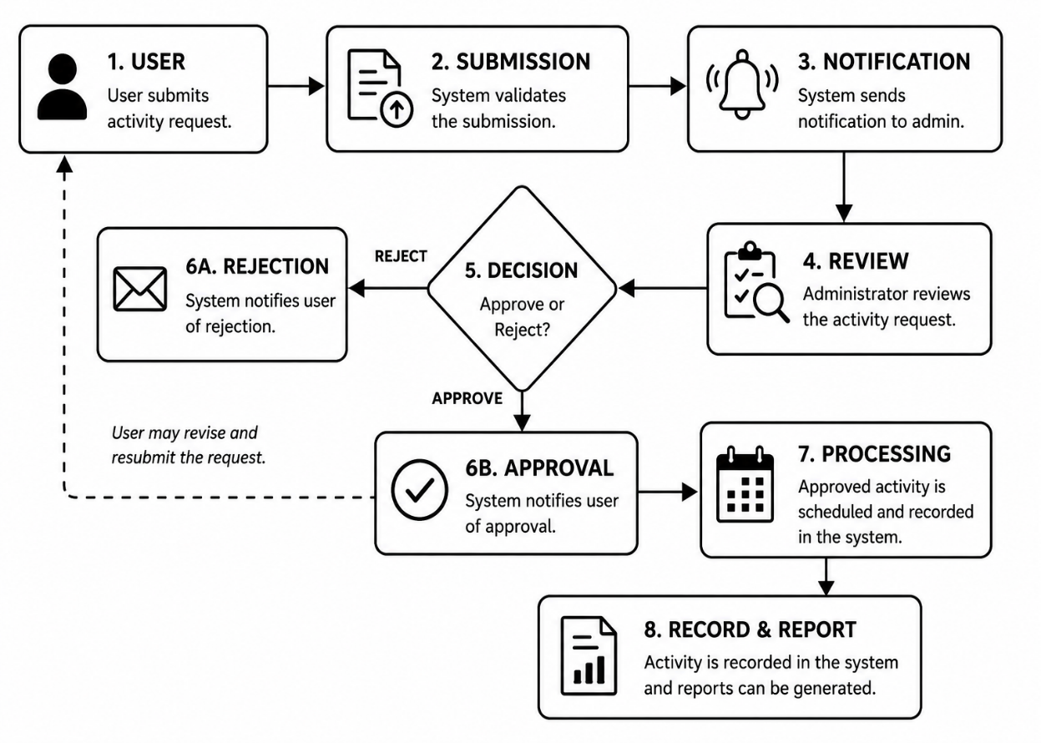

According to Hariprasad et al. (2023) the proposed In/Off Campus Activity Scheduling Information System consists of several major components, namely Activity Submission, Review and Approval, Notification and Tracking, Scheduling Management, and Report Generation. Each component contains specific modules and functions that help streamline the management of in-campus and off-campus student activities. Through this modular structure, the system improves the efficiency of the activity approval process and minimizes the delays, scheduling conflicts, and miscommunication commonly experienced in the traditional paper-based process.
The system addresses the major problems encountered in manual activity management by providing a centralized and automated platform for submitting, reviewing, approving, and monitoring student activities. Student officers can digitally submit activity proposals, upload supporting documents, and track the status of their requests in real time. Advisers, Deans, PSG Council Advisers, Directors, and the Vice President for Academics can review submissions, approve or reject requests, and provide comments through the system. The centralized scheduling feature also helps prevent conflicts in venue, date, and time by detecting overlapping approved activities.
The proposed system is developed to manage and maintain records of both in-campus and off-campus student activities, including their submission, approval workflow, scheduling, and documentation processes. The system assists administrators from the Office of Student Affairs in organizing activity details, monitoring schedules, generating reports, and maintaining activity logs for future reference and decision-making. Furthermore, the system includes notification and reminder features that keep users informed about submission updates, pending approvals, returned requests, and upcoming deadlines. Through these functionalities, the system promotes efficiency, transparency, accessibility, and improved coordination among student officers and university administrators.

Paradigm of the Study
Figure 2. Paradigm of the Study
INPUT |  | PROCESS |  | OUTPUT
- Problems and Challenges faced during the manual In/Off Campus Activity Form process  - Datasets  - Types of  activity  - Activity Details  - Schedule and Venue  - Office of Student Affairs Policy  - ISO 25010  Software  Quality Standard |  | - Analysis of the problems and challenges  - System Development using Agile Scrum Model  - Requirement  Gathering  - Design the Requirement  - Coding  - Testing  - Deployment  - Feedback  - Evaluation of the Developed System using ISO 25010 Software Quality Standard |  | In/Off Campus Activity Scheduling Information System
 |  | FEEDBACK

Figure 3 presented the study's paradigm, encompassing its inputs, processes, and outputs.
The input includes the problems and challenges encountered in the manual activity submission, datasets consisting of types of activity, activity details, schedule and venue and evaluation reports, the policies of Office of Student Affairs, and the ISO/IEC 25010 Software Quality Standard.
The process focused on analyzing the problems and challenges encountered in the current manual system. The Agile Scrum methodology was used for development, which started with gathering and designing the requirements, followed by coding to gradually develop the system features and testing to ensure the system functioned properly. Once approved, the system was deployed for user access, and feedback was gathered for continuous improvement. The developed system was evaluated using ISO 25010 to ensure it met quality standards such as functional suitability, performance efficiency, compatibility, usability, reliability, security, maintainability, and portability.
The output of the developed In/Off Campus Activity Scheduling Information System, which addressed the improved the efficiency of the approval process.

Statement of the Problem
The study aimed to design and develop an In/Off Campus Activity Scheduling Information System designed to monitor and evaluate student officers based on their performance throughout their term. It also sought to provide a centralized platform for recording leadership activities and achievements.
Specifically, the study aimed to address the following:
- What are the problems and challenges encountered by the departments in applying in/off-campus activity forms?
- What system can be developed to address the problems and challenges encountered by the departments?
- What is the extent of compliance of the developed system to ISO 25010 Software Quality standards in terms of?
  - Functional Sustainability
  - Performance Efficiency
  - Compatibility
  - Usability
  - Reliability
  - Security
  - Maintainability
  - Portability
- What enhancements can be made to improve the developed system?

Significance of the Study
This study would benefit the following:
St. Paul University Philippines. By implementing a modern and secure system, the university can enhance its operational efficiency and reputation for technological innovation.
Administrators. The proposed system can greatly assist administrators, particularly those from the Office of Student Affairs (OSA) and council offices, by allowing them to manage and track activity requests in real time. Instead of handling stacks of paper forms, administrators may review, approve, or request revisions for submissions through a single, centralized dashboard. The results of the study may show that administrators experience improved efficiency and reduced workload when using the system.
Departments. Various departments involved in planning and managing student activities can benefit from the system. It may make the scheduling and approval process easier, faster, and more organized. The findings of the study might indicate that departmental coordination and workflow management improve through the system’s use.
Officers. Officers may benefit significantly from the system as it allows them to submit activity proposals, monitor approval status, and receive updates in real time. Instead of relying on manual follow-ups, officers can easily track activities and ensure that all necessary documents are completed and submitted on time. The study may reveal that officers experience more efficient planning and improved communication with other stakeholders through the system.
Advisers. Faculty advisers of student organizations can benefit from a more streamlined process of reviewing and endorsing activity requests. The system may provide them with clear visibility of pending and approved activities, allowing them to guide students more effectively. The results of the study may indicate that advisers experience reduced administrative workload and improved monitoring of student-led activities.
Researchers. This project provides a valuable opportunity to design and implement a system that addresses real-world challenges in activity management. It may offer insights into the needs of the university, faculty, and students, allowing the researcher to contribute to enhancing operational efficiency at St. Paul University Philippines.
Future Researchers. The study may serve as a basis or reference material for future researchers conducting studies related to this topic.

Scope and Limitation
The researchers aimed to design and develop an In/Off Campus Activity Scheduling Information System at St. Paul University Philippines. The system integrates functionalities such as online activity scheduling, submission and approval of activity requests, automated notifications and reminders, centralized activity record management, scheduling conflict detection, and real-time tracking of activity statuses. It also includes a user-friendly portal with a login page that separates the different roles of the users. Student officers can submit activity proposals, upload required documents, and track the progress and status of their activities, while Advisers, Deans, Director, and the VP Acad can manage and monitor the approval workflow, review activity requests, and generate reports through their designated dashboards.
A core feature of the system is the Scheduling Conflict Detector, which helps prevent overlapping activities by automatically identifying conflicts in schedule and venues. This feature assists administrators and approving personnel in reviewing activity requests more efficiently and ensuring proper coordination of campus events. The system is designed to improve the management and organization of in-campus and off-campus activities by reducing manual processes, enhancing communication among users, and promoting efficiency, transparency, and accountability in activity management.
The study focused on the design and development of the In/Off-Campus Activity Scheduling Information System for the Student Affairs and Academic Services of St. Paul University Philippines. Its features include online activity request submission, activity scheduling and monitoring, scheduling conflict detector, approval processing, notification and reminder management, and report generation. However, the system does not include advanced security features to ensure the full protection of activities. It only implements standard security measures to safeguard user data.

Definition of Terms
For a clearer understanding of the study, the following terms are defined:
Approval Process. The formal procedure by which administrators review, approve, reject, or request modifications to submitted activity requests, based on predefined criteria and guidelines.
Compatibility. It refers to the degree to which a product, system, or component can exchange information with other products, systems, or components and perform its required functions while sharing the same hardware or software environment composed of sub-characteristics.
Functional Suitability. It refers to the characteristic of ISO 25010 representing the degree to which a product or system provides functions that meet stated and implied needs when used under specified conditions.
Maintainability. It pertains to the degree of effectiveness and efficiency with which a product or system can be modified to improve it, correct it, or adapt it to changes in environment and requirements.
Performance Efficiency. It refers to the performance relative to the number of resources used under stated conditions.
Portability. It pertains to the degree of effectiveness and efficiency that can transfer a system, product, or component from one hardware, software, or other operational or usage environment to another.
Reliability. It pertains to the degree to which a system, product, or component performs specified functions under specified conditions for a specified period.
Security. It refers to the degree to which a product or system protects information and data so that persons or other products or systems have the degree of data access appropriate to their types and levels of authorization.
Submission of Requests. This is the process in which users input activity details, upload required documents, and submit proposals formally for approval through the interface of the system.
Usability. It pertains to the degree to which specified users can use a product or system to achieve specified goals with effectiveness, efficiency, and satisfaction in a specified context.

CHAPTER 2
METHODOLOGY
This chapter presents the research design, participants of the study, instrumentation, data gathering procedures, and data analysis used for this study.

Research Design
The researchers used descriptive and developmental design methods in the study. The study employed a quantitative approach, specifically a survey method, to evaluate the system's effectiveness and user acceptability based on several criteria: Functional Suitability, Performance Efficiency, Compatibility, Usability, Reliability, Security, Maintainability, and Portability.
The descriptive design helps understand the challenges faced by departments and staff regarding activity management, while the developmental design focuses on improving these challenges through the creation of the In-Off Campus Activity Scheduling Information System. The researcher utilized Agile Scrum development as the basis for the development of the system.
Figure 3. Agile Scrum Development Model

Figure 3 presented the Agile Scrum Development Model, divided into five distinct phases. Each phase is crucial to the success of the project and ensures continuous improvement of the project. Donato (2023) identified five phases:
- Initiation Phase
The first phase, which set the project's foundation, involved creating the project vision by outlining the main objectives, goals, and deliverables. This phase also included identifying the clients and key users involved in the system. In addition, the roles of the researchers were defined to ensure proper task distribution throughout the development process.
As part of this phase, the different system users and their respective responsibilities were identified to clearly define how each user will interact with the system. These user roles served as a basis in designing the system features and functionalities.
Table 1. User Roles in the Scrum Framework
User Role | Description
Product Owner | Represents the client and defines the system requirements and objective.
Scrum Master | Oversees the Agile Scrum process and ensures proper coordination among researchers.
Scrum Team | The researchers responsible for designing, developing, testing, and improving the system.

- Planning Phase
This phase involves the creation of user stories and the development of the sprint backlog. User stories represent the essential requirements and features that must be incorporated into the system. These stories describe the specific functions and actions required by each user role, ensuring that the system design aligns with the needs of the users and the objectives of the study.
The Sprint Backlog serves as a detailed compilation of selected user stories for a specific sprint. It identifies the tasks and activities that the researchers must complete within a given period to achieve the sprint objectives successfully. During sprint planning, the researchers determine the necessary tasks from the sprint backlog and prepare a structured plan for system development and implementation.

Table 2. User Stories for each User Role
User Role | Description
OSA Head | - Reviews activities that have been noted by the Dean  - Can Note (acknowledge/approve) or Reject the activity  - Generate Reports
Dean | - Reviews activities that have been noted by the Adviser  - Can Note (acknowledge/approve) or Reject the activity  - Generate Reports
Advisers | - Reviews activities submitted by students from their assigned department  - Can Note (acknowledge/approve) or Reject the activity  - Generate Reports
Officers | - Fills out activity details (title, date, budget, venue, etc.)  - Uploads attachments (budget file, permit file, supporting documents)  - Submits activities to start the approval workflow (must be at least 5 days before the scheduled date)  - Can edit or resubmit their own activities and track approval status

- Implementation Phase
The implementation phase involves executing tasks and activities required to develop the project product, addressing both software and hardware requirements. The following table outlines the minimum hardware and software specifications necessary for system development and deployment.
Table 3. Hardware Requirements In/Off Campus Activity Scheduling Information System
Hardware | Minimum | Recommended
Processor | Intel Core i5 or AMD Ryzen 5 processor | Intel Core i7 or AMD Ryzen 7 processor
Memory | 8gb or RAM | 16gb of RAM
Storage | 200gb of free disk space | 300gb of free disk space
Display | Resolution of 1024x768 pixels | Resolution of 1920x1080 pixels
Mouse | Optical, Two Primary Buttons, Clickable Scroll Wheel, USB | Optical, Two Primary Buttons, Clickable Scroll Wheel, USB
Keyboard | Wired or Wireless | Wired or Wireless

Table 4. Software Requirements for the In/Off Campus Activity Scheduling Information System
Minimum | Recommended
OS: Windows 10 or later | OS: Windows 10 or later
CPU: 2 Cores | CPU: 4 Cores
RAM: 8gb of RAM | RAM: 16gb of RAM
Storage: At least 200gb | Storage: At least 300gb

- Review and Retrospective Phase
Upon completion of the sprint backlog, a review phase is conducted to evaluate the developed features and system outputs. In this phase, the researchers present the completed functionalities of the In/Off Campus Activity Scheduling Information System to the client for evaluation. The focus of the review is to determine whether the implemented features meet the specified user requirements and system objectives. Feedback from the client is gathered to identify necessary revisions and improvements before final deployment.
Following the review, a retrospective is conducted to assess the overall performance of the development process. The researchers identify challenges encountered, successful practices, and areas that require improvement. Based on these findings, necessary adjustments and enhancements are proposed to improve efficiency and effectiveness in the succeeding phases of development.
- Release Phase
The release phase emphasizes delivering the accepted system to the client and documenting the critical lessons learned throughout the project. This phase ensures that the team captures valuable insights, internalizes best practices, and establishes a foundation for continuous improvement in subsequent development cycles.

System Architecture
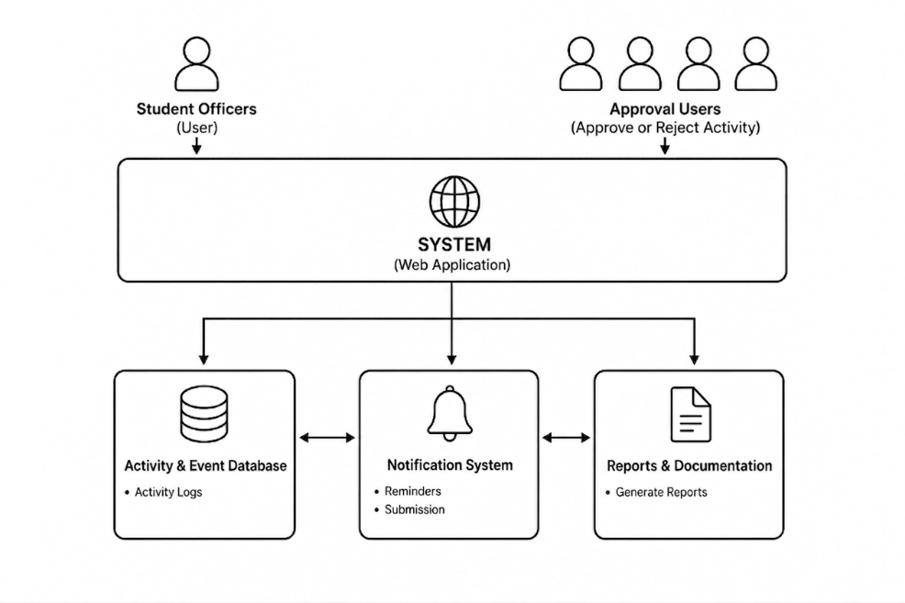
Figure 5. System Architecture of the In/Off Campus Activity Scheduling Information System

Figure 5 illustrates the architecture of the In/Off-Campus Activity Scheduling Information System. The system is a web-based platform developed using Laravel (PHP/MySQL) that streamlines the scheduling, submission, approval, and monitoring of student activities. It allows student officers to submit activity proposals digitally while enabling approvers and administrators to review, approve, or reject requests through a centralized and organized platform. The system also supports activity tracking, scheduling management, notifications, and report generation to improve coordination and communication among users.

The platform automates activity scheduling, approval workflows, and documentation processes, reducing administrative workload and minimizing scheduling conflicts and delays. By centralizing activity management, reminders, submissions, activity logs, and report generation, the system enhances efficiency, transparency, and data management while supporting informed decision-making and effective campus activity coordination.

Participants of the Study
The participants of this study included the OSA Head, advisers, and deans from St. Paul University Philippines. Specifically, the study involved student officers responsible for the submission of in-campus and off-campus activity requests, along with the OSA Head, advisers, and deans who manage, supervise, and approve activities. Additionally, The IT experts provided technical feedback regarding the proposed In/Off-Campus Activity Scheduling Information System.
Table 5. Participants of the Study
Participants | Number | Percentage
OSA Head | 1 | 1%
Advisers | 5 | 7%
Officers | 50 | 70%
Deans | 5 | 7%
IT Experts | 10 | 15%
TOTAL | 71 | 100%

OSA Head. Oversees the overall approval and coordination of all in/off-campus student activities within the system.
Advisers. Review and validate the activity proposals submitted by student officers.
Officers. Initiate and submit in/off-campus activity requests through the system for approval.
Deans. Provide endorsements and academic alignment for proposed student activities.
IT Experts. The people who evaluated the extent of compliance of the developed system with the ISO/IEC 25010 Software Quality Standards.
Instrumentation
To ensure the correctness, adequacy, and appropriateness of the data required during the development process, the researcher used the following:
Interview Guide. The researchers used the interview guide to collect the problems and challenges encountered by the participants.
ISO 25010 Software Quality Standardized Questionnaire. This questionnaire was used by the IT experts in evaluating the developed system using the ISO 25010 Software Quality Standard.

Data-Gathering Procedure
To collect relevant documents and data for the study, the researchers performed the following procedures:
1. The researchers obtained a clearance from the Ethics Review Committee of St. Paul University Philippines to ensure the ethical soundness of the research.
2. The researchers sought endorsement from their thesis advisers and the Dean of the School of Information Technology and Engineering (SITE) for data gathering.
3. The researchers requested permission from the school head to conduct an interview with the Head of Student Affairs Office of St. Paul University Philippines for data gathering.
4. Informed consent/assent from the participants was sought to ensure that the study conforms to the ethical norms of research
5. Upon the approval of the Dean of School of Information Technology and Engineering, the researchers coordinated with the school regarding the details of the gathering.
6. The researchers conducted interviews with the participants. Participants were chosen on a voluntary basis.
7. Direct observations were also made to support what was expressed in the series of participant interviews. The researchers were present to observe how In/Off Campus Activity Form processes are done during the start of the academic year.
8. Furthermore, a questionnaire based on the ISO/IEC 25010:2011 Software Quality Standards was used by the IT experts in assessing the developed system’s extent of compliance with the said standards.

Data Analysis
The gathered quantitative data were collected, tabulated, and treated statistically using the weighted mean, content analysis, and thematic analysis.
Thematic Analysis. This was used to analyze the problems and challenges encountered by the student organization officers in the current manual processes for club registration and renewal.
Weighted Mean. This tool was used to describe the mean responses or evaluation of the IT Experts concerning the system's compliance with ISO 25010 Software Quality Standards.
Table 6. Likert Scale the Developed System’s Compliance with ISO 25010 Software Quality Standard
Weight | Weighted Mean | Descriptive Rating
5 | 4.20 - 5.00 | Very Great Extent
4 | 3.40 - 4.19 | Great Extent
3 | 2.60 - 3.39 | Moderate Extent
2 | 1.80 - 2.59 | Low Extent
1 | 1.00 - 1.79 | Very Low Extent

CHAPTER 3
RESULTS AND DISCUSSION
This chapter presents the results of data analysis and their corresponding discussions. The presentation follows the sequence of the research questions as presented in the statement of the problem.

Problems and Challenges Encountered by the departments in applying for In/Off-Campus Activity forms
Through interviews with the Officers, the following problems were identified:
- Time-Consuming Approval Process
In the manual system, student officers must personally visit different offices or coordinators to secure approvals for in-campus or off-campus activities. This takes a lot of time, especially when several signatories are involved, causing delays in the submission and implementation of activities.
- Scheduling Conflicts of Activities
Without a unified platform, different departments sometimes schedule activities on the same date and venue, creating conflicts. This lack of coordination also makes it difficult for the Office of Student Affairs to manage and allocate resources efficiently.
- Difficulty in Tracking Activity Status
Student officers often experience difficulty monitoring the status of their submitted activity requests because updates are manually communicated. As a result, officers are sometimes unsure whether their requests are approved, pending, or returned for revision.
- Lack of Centralized Record Management
The existing process does not provide a centralized database for storing activity records and approvals. Because of this, retrieving previous activity information and preparing reports become difficult and time-consuming for administrators.

Developed In/Off Campus Activity Scheduling Information System
In response to the growing need for an efficient, transparent, and well-coordinated approach to managing activities, the In/Off-Campus Activity Scheduling Information System was developed. The system makes it easier to submit, review, approve activity requests, and prevent schedule conflicts by improving the flow of information between user roles.
Figure 6. User Login Page
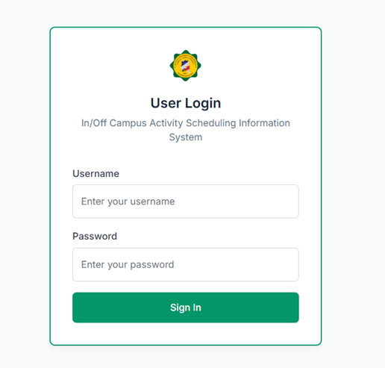

Figure 6 shows the user login page of our system. The login page is where users enter their credentials to securely access the system according to their assigned role.

Figure 7. Admin dashboard
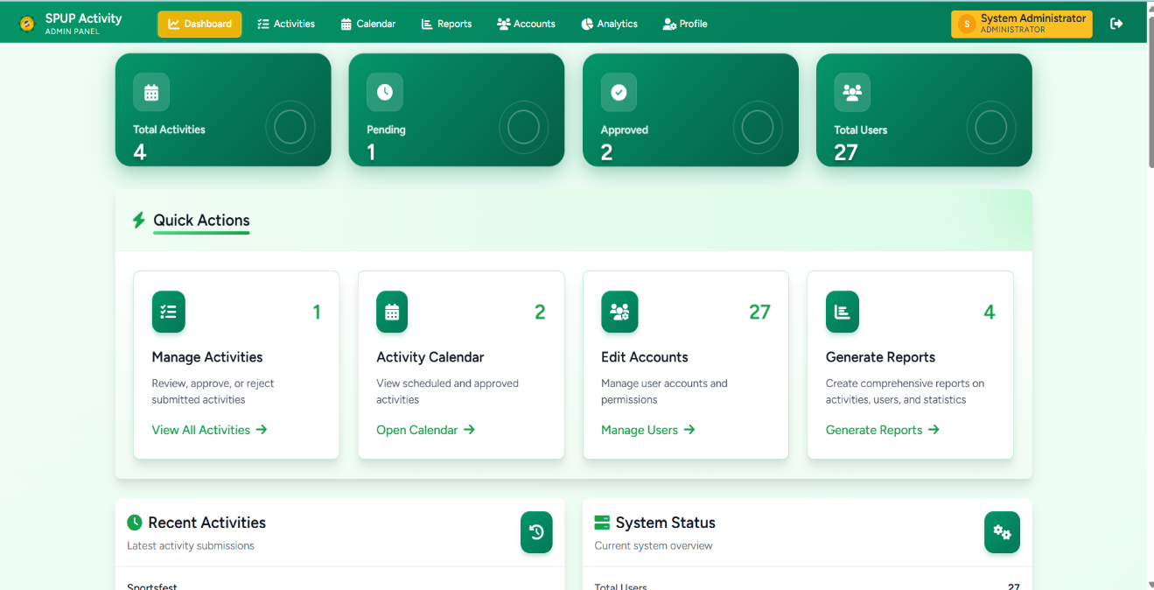
Figure 7 shows the admin dashboard is the control center where administrators see system summaries (e.g., recent activities, status charts, weekly trends) and access management tools like Activities, Accounts, Analytics, and Calendar. It provides quick actions, tables, and visualizations to review, approve, or manage records, plus a calendar view showing approved activities.

Figure 8. Admin Dashboard — Activities Tab
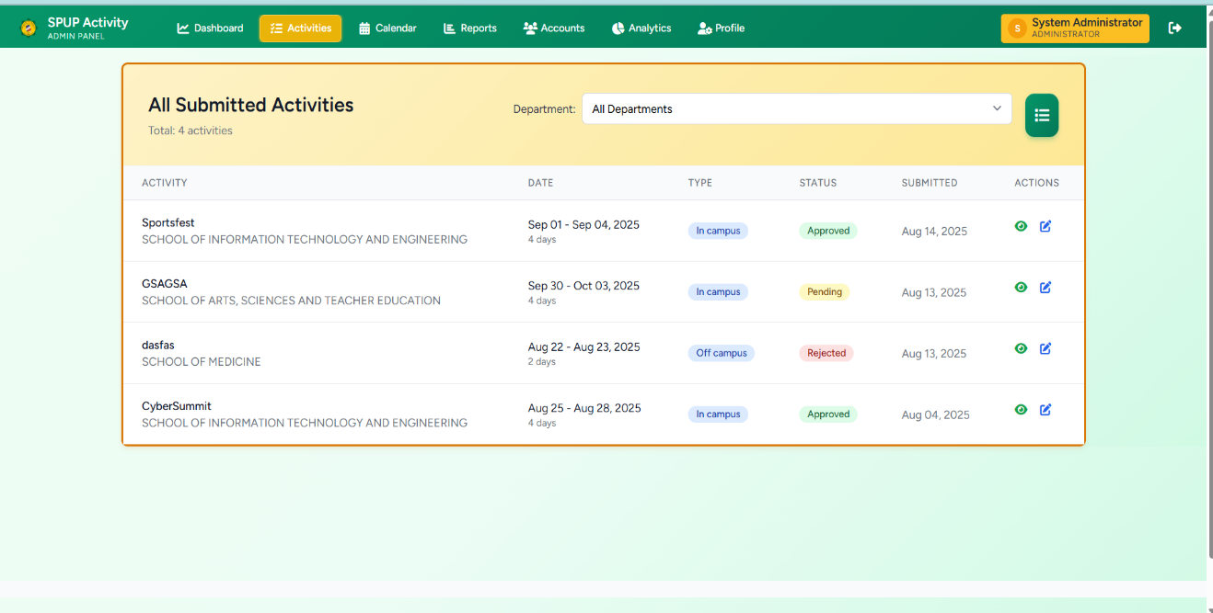
Figure 8 provides administrators with a centralized list of all activities, including their key details and current statuses, for oversight and action. From here, admins can review entries, filter/search, view details, and perform management actions such as approve, return, or delete, ensuring efficient workflow processing.

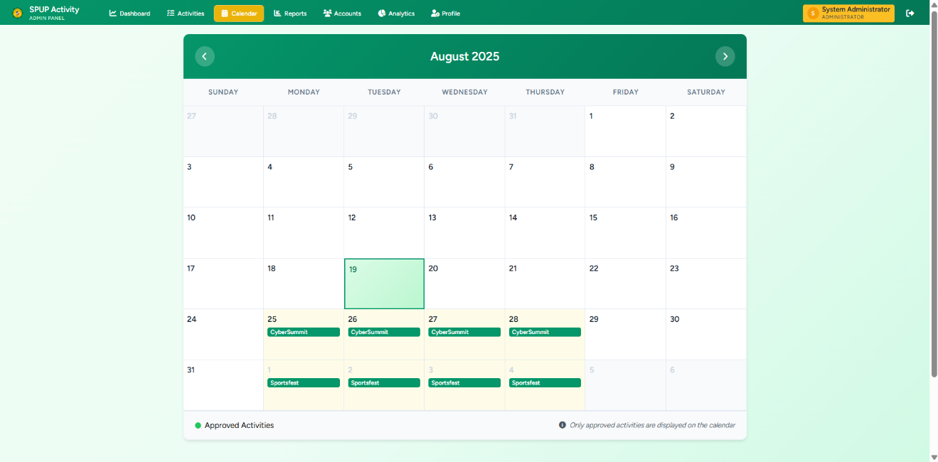
Figure 9. Admin Dashboard — Calendar Tab

Figure 9 displays a calendar view of approved activities, allowing administrators to navigate months, see which days have scheduled events, and click a date to view activity details. It provides a clear and visual schedule to manage timelines.

Figure 10. Admin Reports
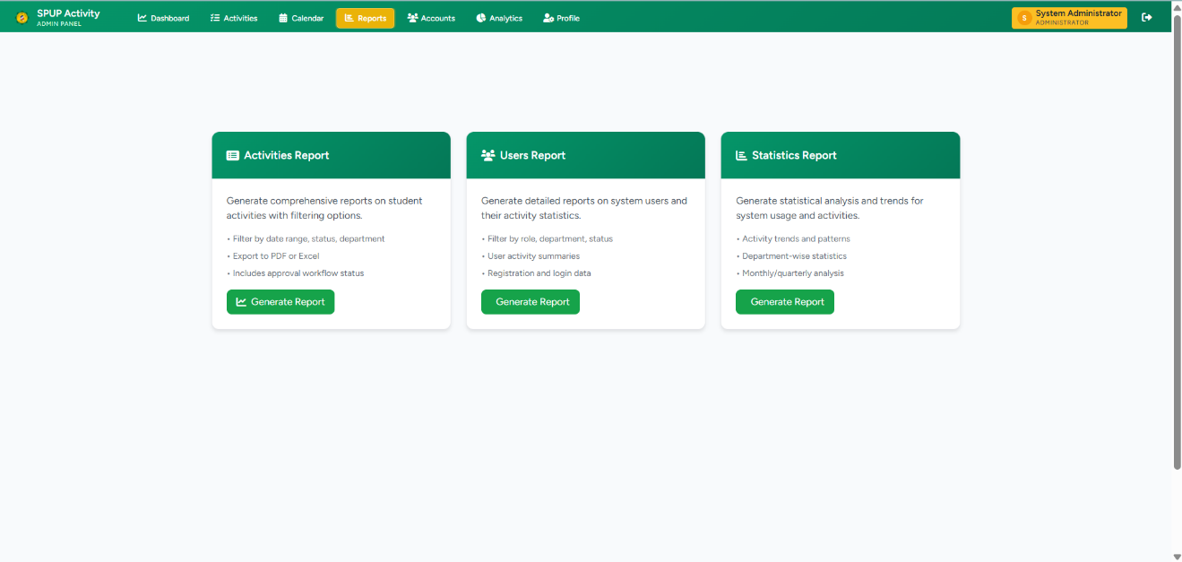
Figure 10 provides administrators with configurable reports and exports summarizing activities, statuses, compliance, and trends across units and time periods. It enables filtered insights and downloadable summaries to support oversight, audits, and data-driven decisions.

Figure 11. Admin Dashboard — Accounts Tab
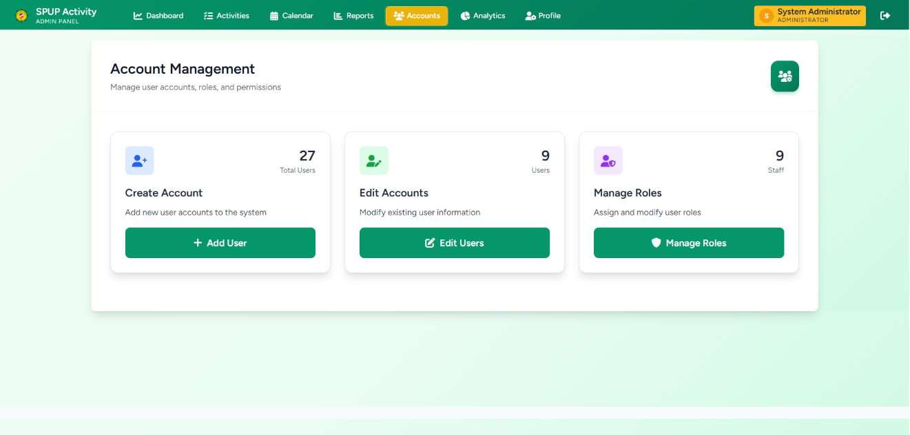
Figure 11 allows administrators to manage user accounts, including creating users, editing profiles, assigning roles/permissions, and activating or deactivating access. It centralizes account oversight to maintain security, ensure appropriate privileges, and keep user information up to date.

Figure 12. Admin Dashboard — Accounts Tab
Figure 12 allows administrators to manage user accounts, including creating users, editing profiles, assigning roles/permissions, and activating or deactivating access. It centralizes account oversight to maintain security, ensure appropriate privileges, and keep user information up to date.

Figure 13. Admin Dashboard — Analytics Tab
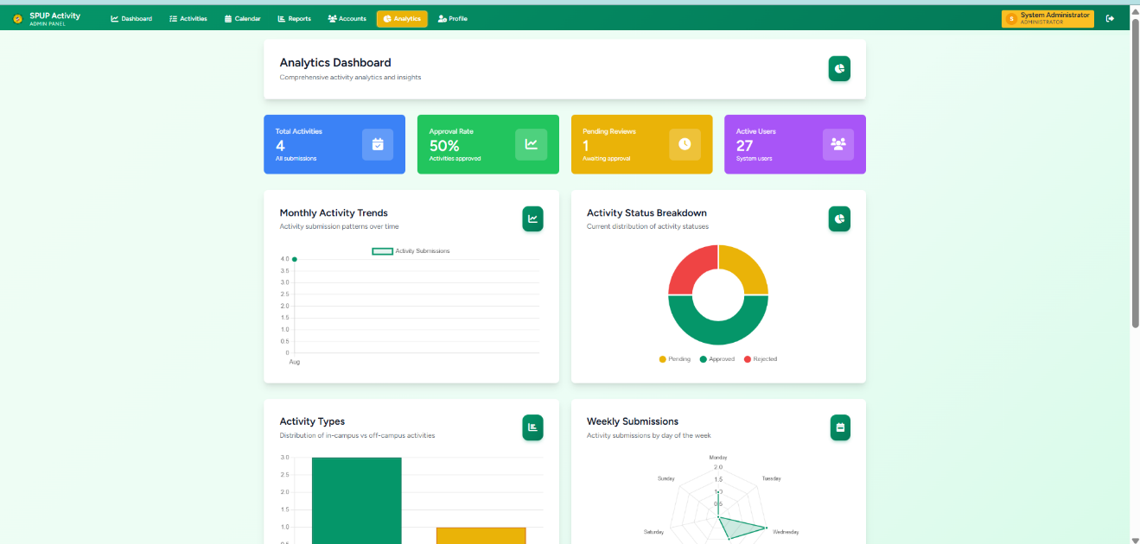
Figure 13 shows simple charts and numbers about activities (how many were submitted, approved, or pending) and when they happen. It helps admins quickly see trends and make decisions based on clear visuals.

Figure 14. Admin Dashboard — Profile Tab
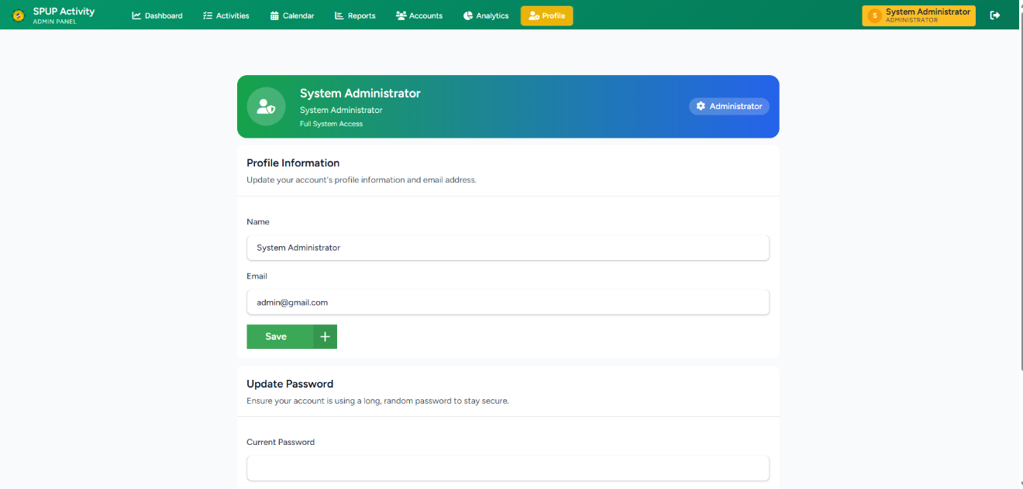
Figure 14 presents an admin view and update their personal information, such as name, email, password, and profile details. It helps keep the account secure and up to date.

Figure 15. Student Officer’s Dashboard
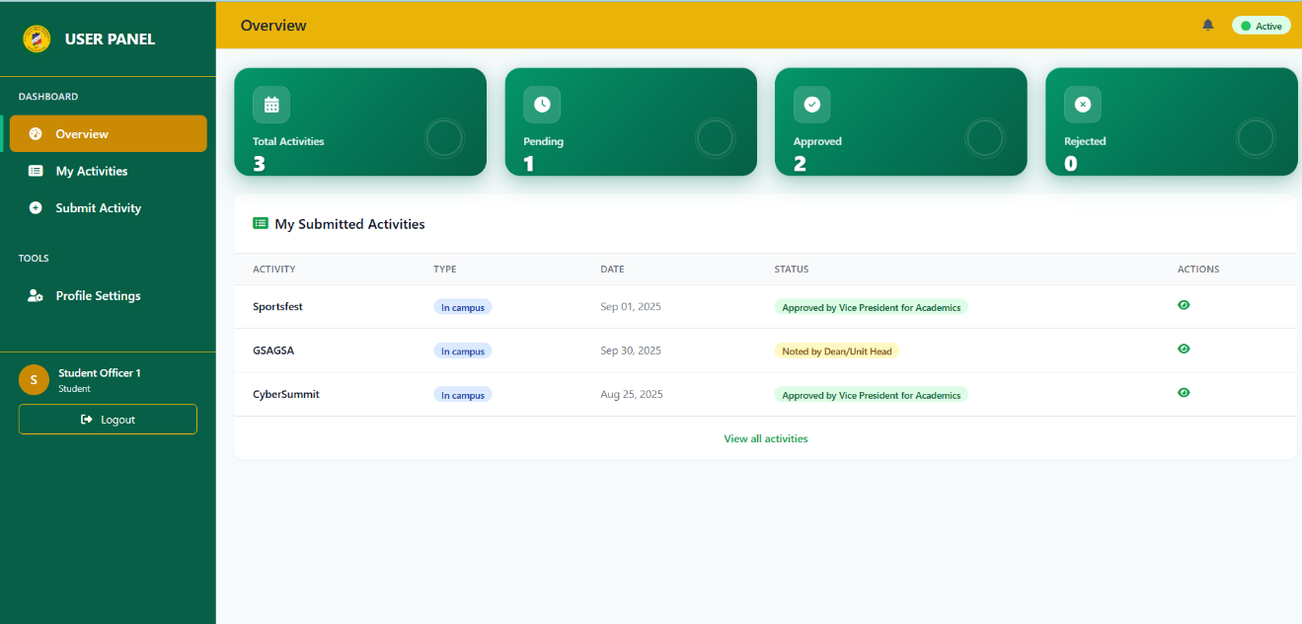
Figure 15 shows the student officer’s dashboard, which provides a quick summary of activities and tasks, including recent submissions, their statuses such as approved, pending, or returned, and important notices. It also offers easy access to submitting new activities, uploading documents, and tracking progress.

Figure 16. Student Officer’s Dashboard
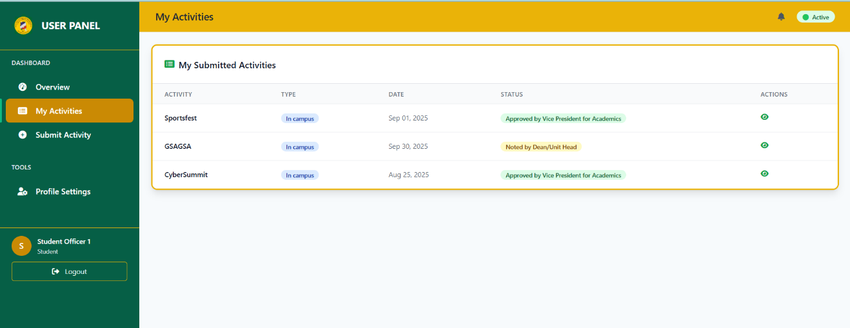
Figure 16 lists all activities submitted by the student officer, showing key details like title, dates, status (draft, pending, returned, approved), and actions. Students can view details, edit or resubmit returned items, create new activities, and track progress in one place.

Figure 17. Student Officer — Create Activity
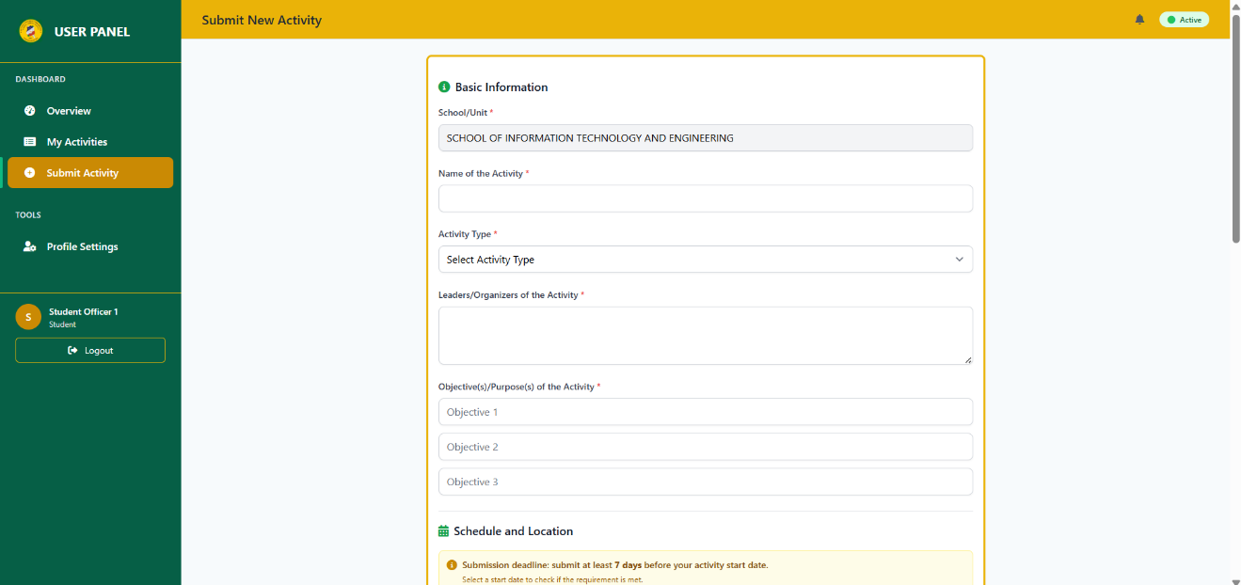
Figure 17 displays the Create Activity feature, which allows a student officer to fill out a form to propose a new activity by entering details such as the title, dates, time, location, and required documents. It enables the student officer to submit the activity or save it as a draft, highlights any missing requirements, and may warn of possible schedule conflicts before the proposal is sent for review.

Figure 18. Student Officer — Profile
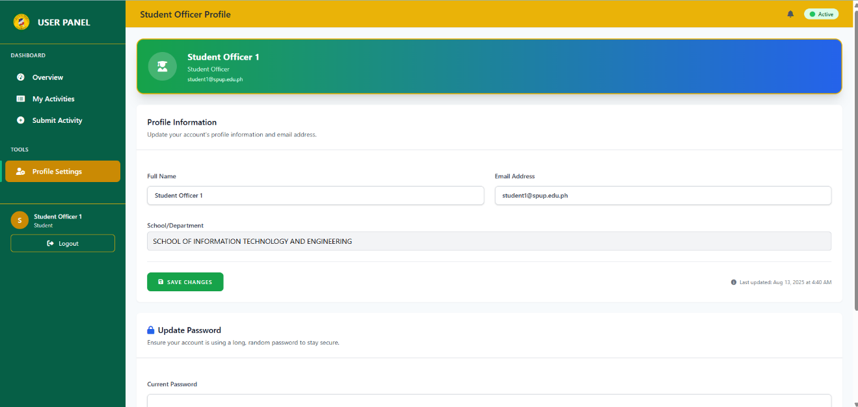
Figure 18 presents the student officer profile, which allows a student officer to view and update personal details such as name, email, password, and contact information, helping keep the account accurate and secure.

Figure 19. Student Officer — Profile
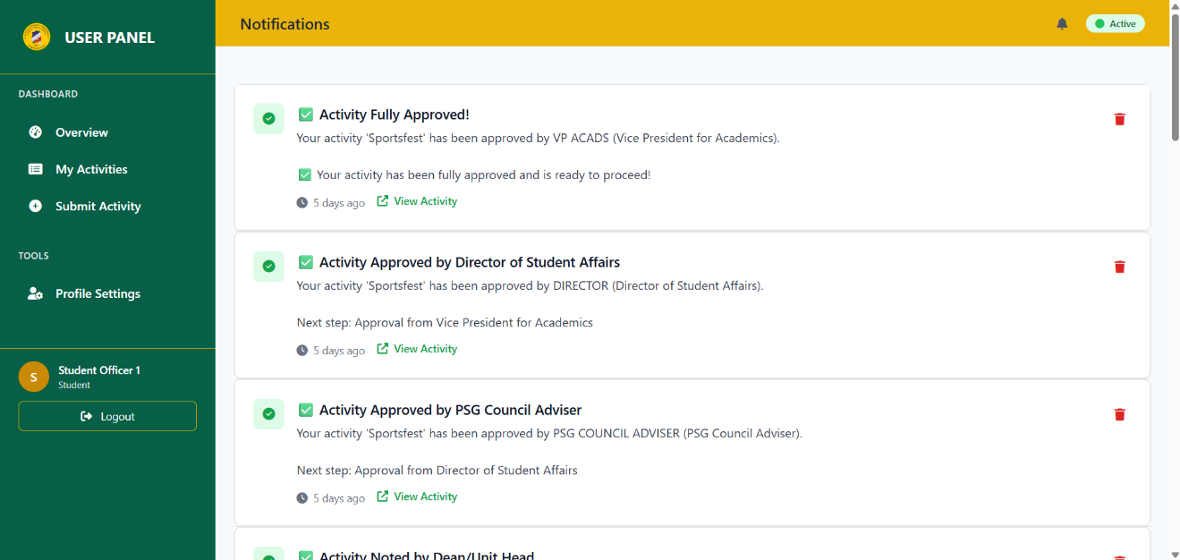
Figure 19 shows all alerts for the student, including submission updates, returned items with comments, approvals, missing documents, and upcoming deadlines. Students can read, mark as read, and follow links to fix issues or view details.

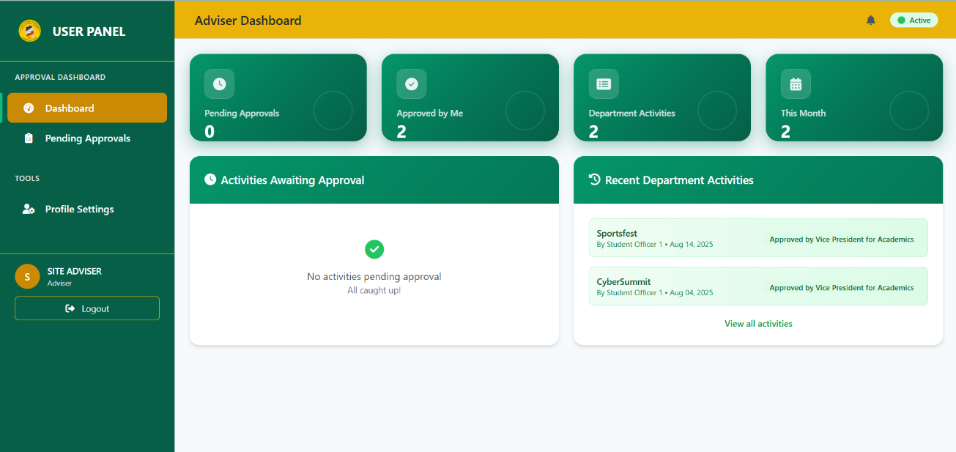
Figure 20. Adviser Dashboard

Figure 20 shows the adviser’s dashboard, which presents a summary of submissions from their students or organizations, including items that need review, those that were returned, and recent actions. From here, the adviser can open items, add comments, endorse or return submissions, and track upcoming deadlines.

Figure 21. Adviser — Pending Approvals
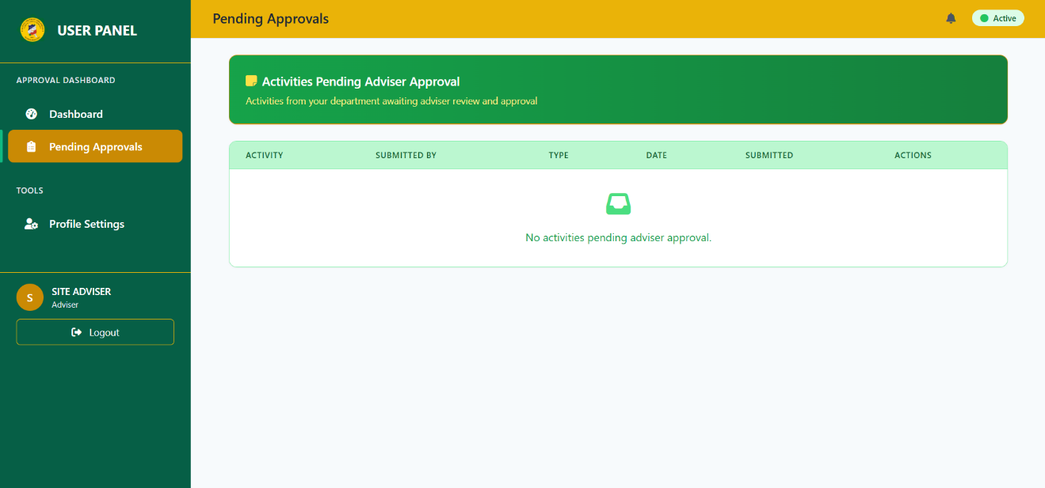
Figure 21 lists all submissions that are waiting for the adviser’s review. The adviser can open each item, check documents, add comments, and either endorse it to the next step or return it for revision.

Figure 22. Adviser Profile
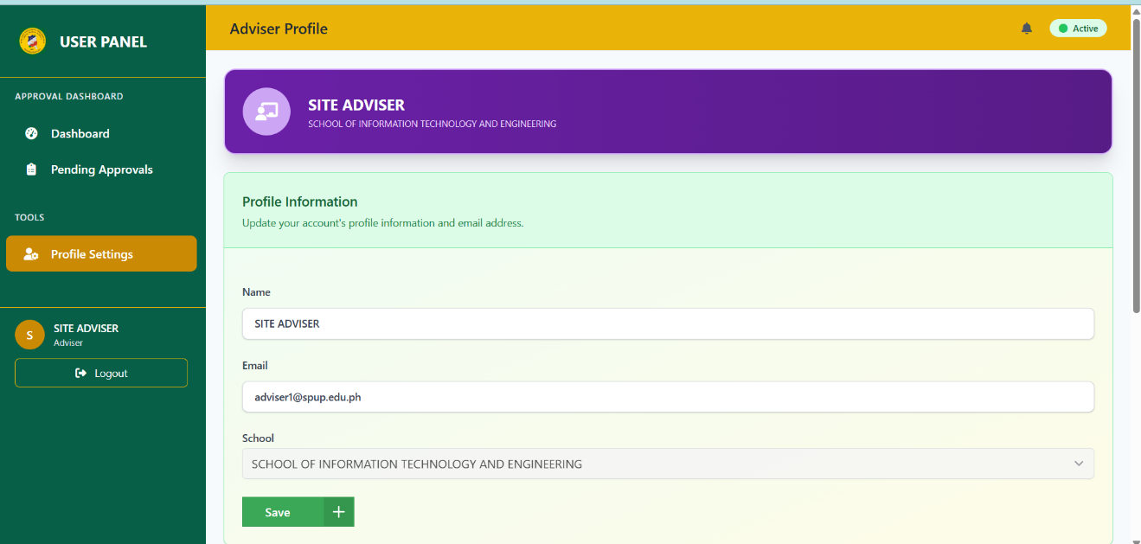
Figure 22 displays the adviser profile, which allows an adviser to view and update account details such as name, email, password, and contact information. It helps keep the profile accurate and secure and may include options to change a profile photo or adjust basic preferences.

Figure 23. Dean Dashboard
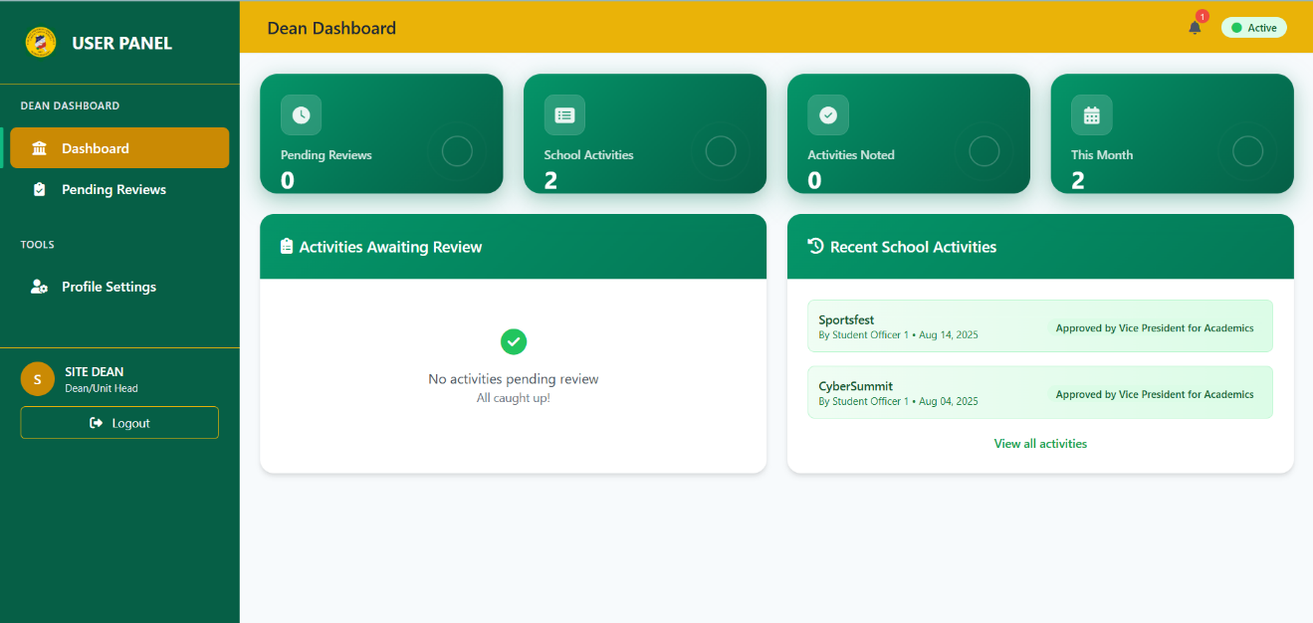
Figure 23 shows the dean’s dashboard, which contains an overview of departmental activities, including those that need review and recently made decisions. The dean can open submissions, check details and schedules, and approve or return them with comments.

Figure 24. Dean — Pending Reviews
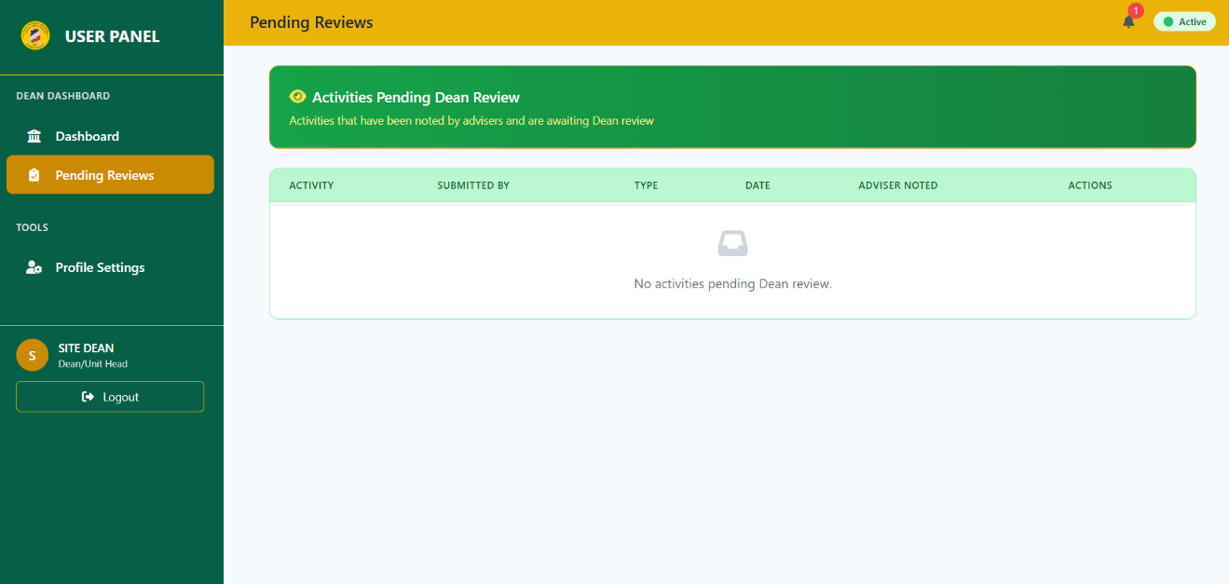
Figure 24 lists all submissions that are waiting for the dean’s review. The dean can open each item, check details and schedules, add comments, and either approve/endorse it or return it for revision.

Figure 25. Dean — Profile
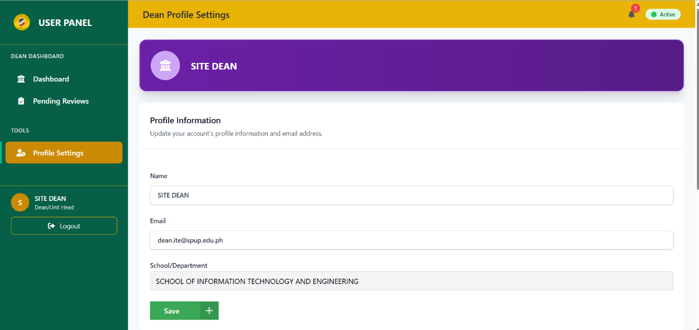
Figure 25 lets the dean view and update their account information, like name, email, password, and contact details. It helps keep the dean’s profile accurate and secure.

Figure 26. PSG Council Adviser Dashboard
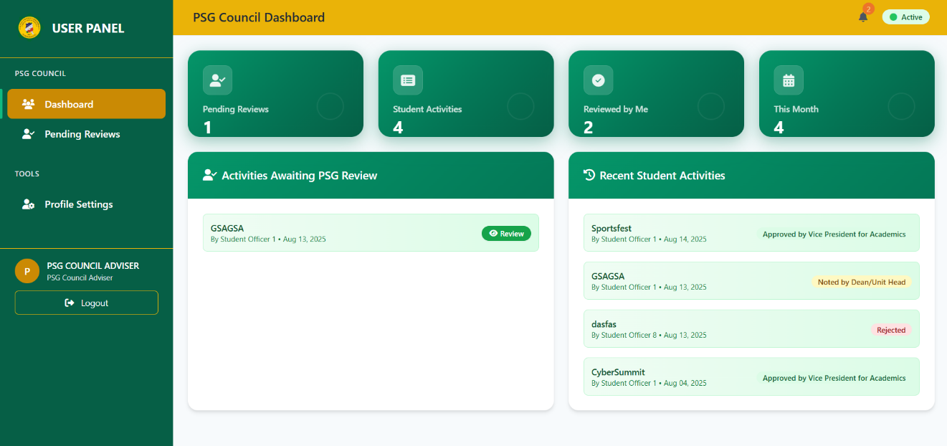
Figure 26 illustrates the PSG council adviser dashboard, which provides a summary of student officer submissions that require attention. From this interface, the PSG council adviser can open items, review documents, provide guidance, and approve or return proposals while tracking recent actions and upcoming deadlines.

Figure 27. Director Dashboard
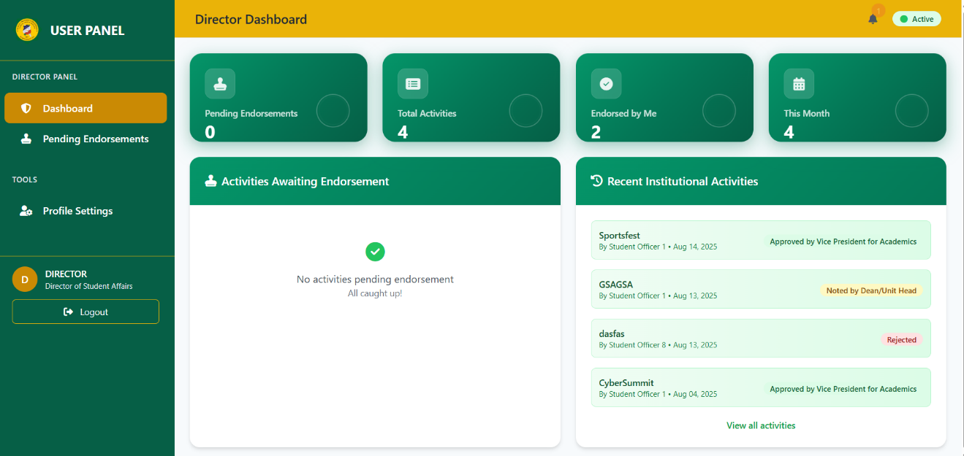
Figure 27 displays the Director Dashboard, which provides a concise overview of institutional activities by highlighting items awaiting endorsement and recent submissions with their current workflow status. It helps directors quickly review, track, and navigate activities that require attention.

Figure 28. Vice President for Academics Dashboard
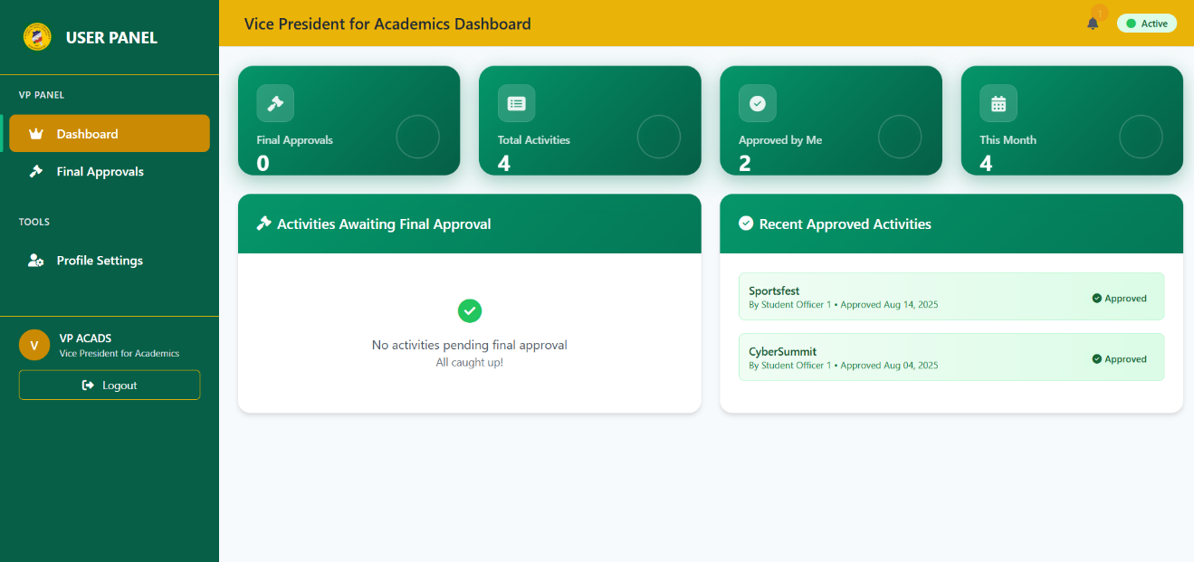
Figure 28 presents the Vice President for Academics and Quality Assurance Dashboard, which provides an overview of activities awaiting final approval and recent institutional submissions, including their current workflow status. It enables the Vice President for Academics and Quality Assurance to quickly review details, make approval decisions, and monitor overall compliance.

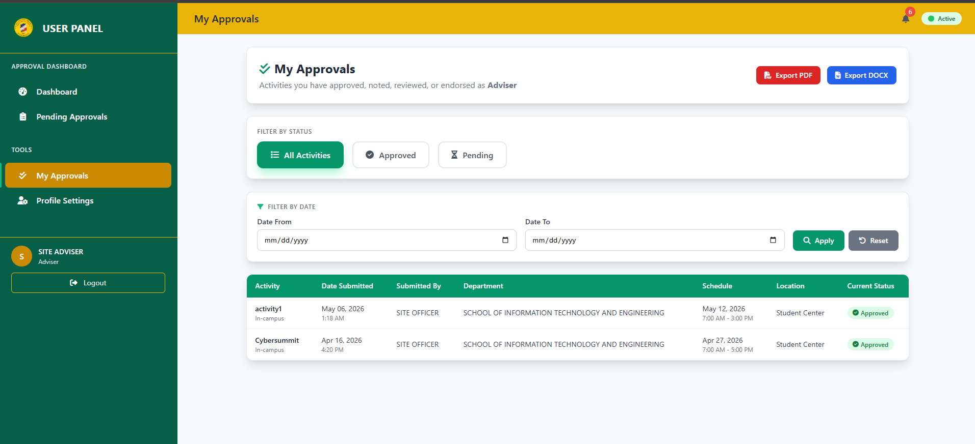
Figure 29. Adviser and Dean’s my approvals page

For Adviser and Dean roles, this page displays a personalized dashboard showing all activities they have personally noted/approved in the workflow. Each can view their approval history with filtering options by status (All/Approved/Pending) and date range, plus an exportable table showing activity details, officer information, and current workflow status. The page allows advisers and deans to track their processed activities and generate PDF or DOCX reports of their approval contributions.

Figure 30. Vice President for Academics, Director, and PSG Council Adviser’s my approvals page
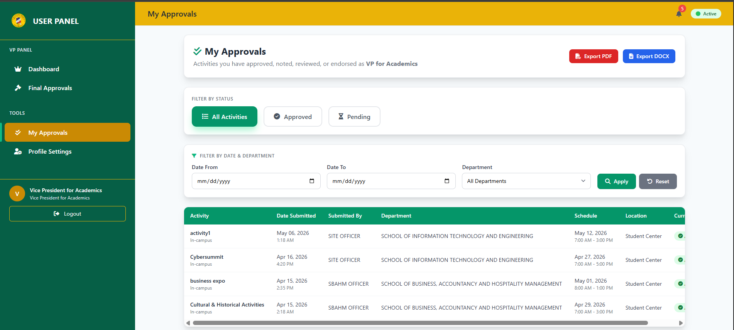
For VP for Academics, Director of Student Affairs, and PSG Council Adviser roles, this page displays a personalized dashboard showing all activities they have personally approved/endorsed/reviewed in the workflow. Each can view their approval history with filtering options by status (All/Approved/Pending), date range, and department, plus an exportable table showing activity details, student information, and current workflow status.

Extent of Compliance with ISO/IEC 25010 Software Quality Standard
To evaluate the extent of compliance of the developed system with the ISO/IEC 25010 Software Quality Standards, ten IT experts were chosen to evaluate the system.
The following tables present the result of their assessment.
Table 7. Extent of Compliance of the Developed System with ISO/IEC 25010 Software Quality Standards in Terms of Functional Suitability
Indicators | Mean | Descriptive Interpretation
1. Functional completeness. The system covers all the specified tasks and user objectives. | 4.20 | Very Great Extent
2. Functional correctness. The system provides the correct results with the needed degree of precision. | 4.23 | Very Great Extent
3. Functional appropriateness. The system functions facilitate the accomplishment of specified tasks and objectives. | 4.21 | Very Great Extent
Category Mean | 4.21 | Very Great Extent
Table 7 presents the extent of compliance of the developed system in terms of functional suitability.
The results show an average score of 4.21, which is described as “Very Great Extent.” This indicates that the system effectively performs its intended tasks, produces correct results, and helps users accomplish their goals efficiently.
The results are consistent with the findings of Kaber et al. (2021), wherein a system that obtains high ratings in the Functional Suitability standard of the ISO/IEC 25010 Software Quality Standards can be concluded to be reliable in executing its system functions and ready for deployment.
Table 8. Extent of Compliance of the Developed System with ISO/IEC 25010 Software Quality Standards in Terms of Performance Efficiency
Indicators | Mean | Descriptive Interpretation
1. Time Behavior. The system meets its requirements in terms of responses, processing times, and throughput rates when performing its functions. | 4.22 | Very Great Extent
2. Resource Utilization. The system maximizes the utilization of available resources. (i.e., people, data, machine, and material) efficiently. | 4.20 | Very Great Extent
3. Capacity. The system meets its requirements up to its maximum limits. | 4.25 | Very Great Extent
Category Mean | 4.22 | Very Great Extent

Table 8 presents the extent of compliance of the developed system in terms of performance efficiency.
The results show an average score of 4.22, which is interpreted as “Very Great Extent.” This indicates that the system runs smoothly, responds quickly to user requests, and efficiently utilizes computing resources without noticeable delays or limitations.
The results are further supported by the findings of Joter et al. (2024), wherein performance efficiency is identified as a crucial aspect of software quality, particularly in modern systems that process large volumes of data, support multiple concurrent users, and handle complex operations.

Table 9. Extent of Compliance of the Developed System with ISO/IEC 25010 Software Quality Standards in Terms of Compatibility
Indicators | Mean | Descriptive Interpretation
1. Co-existence. The system can perform its required functions efficiently while sharing a common environment and resources with other products, without detrimental impact on any other product. | 4.30 | Very Great Extent
2. Interoperability. The system can exchange information and use the information that has been exchanged. | 4.30 | Very Great Extent
Category Mean | 4.30 | Very Great Extent

Table 9 presents the extent of compliance of the developed system in terms of compatibility.
The results show an average score of 4.30, which falls under the “Very Great Extent” category. This indicates that the system can effectively work with other software systems without causing issues.
The results are reinforced with the findings of Yang (2023), wherein compatibility is important for systems that use API-based or operate in hybrid environments that require integration with other systems.
Table 10. Extent of Compliance of the Developed System with ISO/IEC 25010 Software Quality Standards in Terms of Usability
Indicators | Mean | Descriptive Interpretation
1.Appropriateness Recognizability. The system allows users to recognize if it is appropriate for their needs | 4.20 | Very Great Extent
2. Learnability. The system can be used by specified users to achieve specific goals of learning to use the application with effectiveness, efficiency, freedom from risk and satisfaction in a specified context of use. | 4.23 | Very Great Extent
3. Operability. The system has attributes that make it easy to operate and control. | 4.20 | Very Great Extent
4. User Error Protection. The system protects users against making errors. | 4.24 | Very Great Extent
5. User Interface Aesthetics. The system’s user interface enables pleasing and satisfying interaction for the user. | 4.20 | Very Great Extent
6. Accessibility. The system can be used by people with the widest range of characteristics and capabilities to achieve a specified goal in a specified context of use. | 4.22 | Very Great Extent
Category Mean | 4.21 | Very Great Extent

Table 10 presents the extent of compliance of the developed system in terms of usability.
The results show an average score of 4.21, which falls under the “Very Great Extent” category. This indicates that the system is easy to learn, understand, and use, contributing to a positive user experience.
The findings suggest that the system is user-friendly, visually appealing, and easy to learn and operate, which contributes to a positive user experience. These results support the study of Sena et al. (2021), which emphasized that usability plays a significant role in the successful adoption of institutional technologies.

Table 11. Extent of Compliance of the Developed System with ISO/IEC 25010 Software Quality Standards in Terms of Reliability
Indicators | Mean | Descriptive Interpretation
1. Maturity. The system meets the needs for reliability under normal operation. | 4.20 | Very Great Extent
2. Availability. The system is operational and accessible when required for use. | 4.30 | Very Great Extent
3. Fault tolerance. The system operates as intended despite the presence of hardware and software faults. | 4.20 | Very Great Extent
4. Recoverability. The system can recover the data directly affected and re-established the desired state. | 4.30 | Very Great Extent
Category Mean | 4.25 | Very Great Extent

Table 11 presents the extent of compliance of the developed system in terms of reliability.
The results show an average score of 4.25, which is interpreted as “Very Great Extent.” This indicates that users can depend on the system to perform consistently under normal conditions, remain available when needed, and maintain data integrity even when errors or issues occur.
The findings imply that the system is consistently accessible and capable of performing its intended functions under normal operating conditions while maintaining acceptable recovery and fault-handling capabilities. These results support the study of Guza (2023), which emphasized that reliable digital systems are essential for ensuring uninterrupted organizational and administrative processes.

Table 12. Extent of Compliance of the Developed System with ISO/IEC 25010 Software Quality Standards in Terms of Security
Indicators | Mean | Descriptive Interpretation
1. Confidentiality. The system ensures that data is accessible only to those authorized to have access. | 4.25 | Very Great Extent
2. Integrity. The system is developed to prevent unauthorized access to, or modification of computer programs and data. | 4.22 | Very Great Extent
3. Non-repudiation. The system’s event can be proven to have taken place and cannot be repudiated. | 4.28 | Very Great Extent
4. Accountability. The system’s action of an entity can be traced uniquely to the entity. | 4.23 | Very Great Extent
5 Authenticity. The system’s identity of a subject or resource can be proved to be the one claimed. | 4.30 | Very Great Extent
Category Mean | 4.25 | Very Great Extent

Table 12 presents the extent of compliance of the developed system in terms of security.
The results show an average score of 4.25, which falls under the “Very Great Extent” category. This indicates that the system has effective security measures to protect sensitive credential information and ensure that all data and transactions remain secure.
The results are further reinforced by the findings of Alexandre et al. (2025), wherein security performance is important in credential processing systems, since student information is vulnerable to privacy risks, as academic offices such as the registrar handle and distribute sensitive personal data.

Table 13. Extent of Compliance of the Developed System with ISO/IEC 25010 Software Quality Standards in Terms of Maintainability
Indicators | Mean | Descriptive Interpretation
1. Modularity. The system is composed of discrete components such that a change to one component has minimal impact on other components. | 4.40 | Very Great Extent
2. Reusability. The system’s assets can be used in more than one system, or in building other assets. | 4.20 | Very Great Extent
3. Analyzability. The system has the possibility to assess the impact on a product or system of an intended change to one or more of its parts, or to diagnose a product for deficiencies or causes of failures, or to identify parts to be modified. | 4.20 | Very Great Extent
4. Modifiability. The system can be effectively and efficiently modified without introducing defects or degrading existing product quality. | 4.30 | Very Great Extent
5. Testability. The system can establish test criteria and test can be performed to determine whether those criteria have been met. | 4.20 | Very Great Extent
Category Mean | 4.26 | Very Great Extent

Table 13 presents the extent of compliance of the developed system in terms of maintainability.
The results show that the system obtained a category mean of 4.26, which is interpreted as “Very Great Extent.” This indicates that the system is easy to maintain in terms of implementing changes and identifying issues.
The results are consistent with the findings of Munguia et al. (2021), wherein the importance of this characteristic goes beyond the development stage, as maintainability focuses on the long-term sustainability and adaptability of software systems.

Table 14. Extent of Compliance of the Developed System with ISO/IEC 25010 Software Quality Standards in Terms of Portability
Indicators | Mean | Descriptive Interpretation
1. Adaptability. The system can effectively and efficiently be adapted for different or evolving hardware, software or other operational or usage environments. | 4.30 | Very Great Extent
2. Installability. The system can be successfully installed and/or uninstalled in a specified environment | 4.30 | Very Great Extent
3. Replaceability. The system can replace another specified software | 4.30 | Very Great Extent
Category Mean | 4.30 | Very Great Extent

Table 14 presents the extent of compliance of the developed system in terms of portability.
The results show a category mean of 4.30, which is interpreted as “Very Great Extent.” This indicates that the system is flexible and can be deployed in different technological environments without major issues in installation or portability.
The results are further supported by the findings of Barera et al. (2019), wherein portability is identified as one of the key criteria used in assessing academic management systems in Philippine higher education institutions.
Table 15. Summary on the IT Experts’ Evaluation on the Extent of Compliance of the Developed System with ISO 25010 Software Quality Standards
ISO/IEC 25010 Characteristics Criteria | Criteria Mean | Descriptive Interpretation
A. Functional Suitability | 4.21 | Very Great Extent
B. Performance Efficiency | 4.22 | Very Great Extent
C. Compatibility | 4.30 | Very Great Extent
D. Usability | 4.21 | Very Great Extent
E. Reliability | 4.25 | Very Great Extent
F. Security | 4.25 | Very Great Extent
G. Maintainability | 4.26 | Very Great Extent
H. Portability | 4.30 | Very Great Extent
Overall Mean | 4.25 | Very Great Extent

Table 15 presents the overall result of the system evaluation in compliance with ISO 25010 Software Quality Standards.
The results show that the system obtained an overall mean of 4.25, interpreted as “Very Great Extent,” indicating strong compliance with the ISO 25010 software quality standards across all evaluated characteristics. This implies that the developed system is reliable, secure, usable, efficient, maintainable, and adaptable, making it suitable for effective implementation and long-term use.
These findings support the study of Juda (2023), which emphasized that online systems enhance operational efficiency, reduce manual processes, and improve the overall effectiveness of organizational management through accessible and reliable digital solutions.

Recommended Enhancements for In/Off Campus Activity Scheduling Information System
• Improve Scheduling and Conflict Detection Features
The experts recommended enhancing the scheduling and conflict detection capabilities of the system to ensure more accurate management of in-campus and off-campus activities. They emphasized the importance of implementing automatic conflict detection for schedules, venues, and overlapping events to minimize errors and avoid duplication of activities. In addition, the system should provide real-time notifications and reminders to officers, advisers, and administrators regarding pending requests, approved activities, and schedule changes. It was also suggested that the calendar interface be improved to allow users to easily monitor and track upcoming events and reservations.
• Implement Notification System
The experts recommended integrating a notification and alert system to improve communication and ensure that users remain informed about important updates within the In/Off Campus Activity Scheduling Information System. The system should provide automated notifications for activity approvals, rejections, pending requests, schedule conflicts, and upcoming events. Notifications may be sent through in-system alerts and email messages to organization officers, advisers, deans, and administrators. In addition, reminder notifications for deadlines, document submissions, and scheduled activities should be included to help users manage responsibilities more efficiently and reduce the possibility of missed schedules or incomplete requirements.
- Use Middleware in the Login Page
The experts also recommended implementing middleware in the login page to strengthen the security and access control of the system. Middleware can help authenticate users and ensure that only authorized users are allowed to access specific modules and features based on their assigned roles, such as Student officers, Advisers, Deans, Directors, VP Acad. Through middleware implementation, unauthorized access to confidential activity records and administrative functions can be prevented.

CHAPTER 4
SUMMARY OF FINDING, CONCLUSION, AND RECCOMENDATIONS
This chapter presents the summary of findings, conclusion, and recommendations based on the results of the study.

Summary of Findings
The results of the study are summarized as follows:
1. Problems and Challenges Encountered by the departments in Applying In/Off Campus Activity Forms Through observations, surveys and interviews with teachers and officers from St. Paul University Philippines,
The following problems were identified:
1.1 Time-Consuming Approval Process
  - Scheduling Conflicts of Activities
- Development of In/Off Campus Activity Scheduling Information System
The In/Off Campus Activity Scheduling Information System was developed in response to the problems and challenges encountered in applying activity form. The project aims to optimize and digitize the activity form procedures across different college departments within the institution by integrating key features such as online activity submission, automated notifications and reminders, centralized activity records, real-time tracking of activity status, role-based dashboards for different users, and a Scheduling Conflict Detector that identifies overlapping schedules and prevents activity conflicts. This provides a more efficient, organized, and accessible system for both administrators and student organizations.
3. Extent of Compliance of the Developed System with the ISO 25010 Software Quality Standard
The developed system evaluated by IT experts meets the ISO/IEC 25010 Software Quality Standard to "Very Great Extent" in terms of functional suitability, performance efficiency, compatibility, usability, reliability, security, maintainability, and portability.
4. Recommended enhancements for the Developed system:
- Improve Scheduling and Conflict Detection Features
- Implement Notification System
- Use Middleware in the Login Page

Conclusion
Based on the findings of this study, the following conclusions were drawn:
The In/Off Campus Activity Scheduling Information System addressed the challenges of manual scheduling, inefficient activity monitoring, Schedule conflicts, and the absence of a centralized platform for managing in-campus and off-campus activities. By digitizing the scheduling and approval processes and integrating features such as automated conflict detection, activity tracking, notification systems, and centralized record management, the system improved efficiency, accuracy, and overall coordination among student organizations and administrators. The results revealed that the system obtained a rating of “Very Great Extent.” Therefore, the developed system complies with the ISO/IEC 25010 Software Quality Standards and can be utilized to enhance institutional efficiency and address challenges encountered in managing student organization activities.

Recommendations
Based on the findings and conclusions drawn, the researcher recommends the following:
- St. Paul University Philippines may implement the developed system.
- Student Affairs and Academic Services may consider supporting the implementation of the developed system.
- The researcher may present the findings of the study at St. Paul University Philippines.
- Future researchers enhance the developed system by conducting further study on the system and consider integrating an announcement or posting module and live chat feature.

REFERENCES
Ahmed, [R. A.], et al. (2024). AI-enhanced activity management systems in higher education: Automation, personalization, and decision-making. [Journal of Educational Technology].
Alar, [C. F.], et al. (2023). Performance evaluation and continuous improvement in software quality assessment. [Journal of Software Engineering and Applications].
Alexandre, [T. E.], et al. (2025). Security performance in credential processing systems: Protecting student information. [International Journal of Information Security].
Almeida, [J. Q.], et al. (2023). Centralized, technology-driven activity management systems in educational institutions. [Journal of Educational Administration and Technology].
Arunk, [M. R.], et al. (2024). IoT integration in smart campus systems: Real-time data collection and activity management. [Internet of Things and Smart Environments Journal].
Balu, [Z. A.], et al. (2021). Smart Event Management System: Addressing data management challenges in educational institutions. [Journal of Information Systems and Technology Management].
Barera, [P. M.], et al. (2019). Portability as a key criterion in assessing academic management systems in Philippine higher education. [Philippine Journal of Information and Communication Technology].
Behjin, [W. Q.], & Avija, [F. A.] (2021). Security and maintainability in software systems: Continuous monitoring and improvement strategies. [Journal of Systems and Software].
Bregabiel, [G. A.], & Santia, [F. A.] (2024). Automated systems for improving operational efficiency, transparency, and decision-making across sectors. [Journal of Organizational Automation].
Bregabriel, [A. Y.], et al. (2024). Digital solutions for administrative workflow improvement in Philippine educational institutions. [Philippine Journal of Educational Management].
Brown, [T. J.], et al. (2024). Digital platforms in schools: Increasing student participation through simplified interfaces and timely notifications. [Journal of Educational Technology and Society].
Canlas, [R. O.], et al. (2021). Usability standards in ISO/IEC 25010: Evaluation of educational management systems. [Philippine Journal of Computing and Information Sciences].
Connor, O., [G. H.], et al. (2024). Mobile platforms for event management: Increasing student participation and volunteerism in campus activities. [Journal of Mobile Computing in Education].
Devi, [P. I.], et al. (2021). Integrated Validation System (IVS): Optimizing administrative procedures and student activity management. [Journal of Educational Administration].
Donato, [W. V.] (2023). Agile Scrum development methodology: Five phases for successful project implementation. [Journal of Software Development and Agile Practices].
Estoke, [R. G.], et al. (2024). IoT integration in campus activity management: Improving decision-making and operational efficiency. [Smart Campus Technology Journal].
Falasi, [U. T.], et al. (2022). Reporting tools in campus event management systems: Evaluating event performance and improving administrative planning. [Journal of Higher Education Administration].
Garcia, [I. A.], et al. (2022). Shared calendar features in activity management systems: Organizing events and preventing schedule conflicts. [Journal of Educational Information Systems].
Hadiwiyanti, [A. F.], et al. (2021). Campus Event Management Information System: Addressing event management challenges at a university in East Java. [Journal of Information Technology and Computer Science].
Hall, [S. L.], et al. (2022). Real-time tracking and improved communication systems in educational institutions. [International Journal of Educational Management].
Hariprasad, [R. R.], et al. (2023). College Club Activity Management System: A platform for managing student clubs, memberships, events, and communication. [Journal of Campus Information Systems].
Hassan, [F. W.], et al. (2024). Web-based event management systems: Features for event submission, approval, tracking, and real-time notifications. [Journal of Web-Based Systems in Education].
Ivanov, [T. R.], et al. (2021). Automated event management in educational settings: Workshops, conferences, and school activities. [Journal of Educational Technology and Information Systems].
Johnson, [G. R.], et al. (2024). Combining event, attendance, and duty management into unified campus activity systems. [Journal of Integrated Campus Management].
Jom, [O. Y.], & Sel, [F. A.], et al. (2023). Internet of Things (IoT) technology in school campus administration: Improving activity-related system management. [IoT in Education Journal].
Juluget, [G. F.], et al. (2024). Performance efficiency as a crucial aspect of software quality in modern information systems. [Journal of Software Quality and Performance].
Kaabi, [C. K.], et al. (2023). Online event organizer platform for managing technical and non-technical events in schools. [Journal of Educational Systems Design].
Kaabi, [I. R.], et al. (2024). Digital campus management systems: Event coordination, attendance tracking, and duty roster management. [International Journal of Campus Management Technology].
Kaber, [T. K.], et al. (2021). Functional suitability standards under ISO/IEC 25010: Evaluation and assessment in academic management systems. [Journal of Software Engineering Research].
Kovalenko, [I. G.], et al. (2023). Student-centered features in online event management apps: Registration, attendance tracking, and payments. [Journal of Educational Mobile Applications].
Kumarp, [L. O.] (2024). Improving student activity management and communication through technology-based systems in schools. [Journal of Campus Digital Transformation].
Kuznetsova, [I. C.], et al. (2021). Integrated Verification System (IVS): Streamlining submission and approval of student activity proposals. [Journal of Higher Education Administration and Technology].
Larse, [L. D.], et al. (2024). Technology advances in managing campus activities and administrative processes in higher education. [International Journal of Educational Technology].
Laudon, K. C., [E. W.], et al. (2021). Activity management systems and their role in institutional operational efficiency. [Management Information Systems: Managing the Digital Firm]. Pearson.
Lavania, [J. R.], et al. (2023). Online Event Management mobile application: Solving administrative challenges in school event coordination. [Journal of Mobile Application Development in Education].
Lopez, [G. S.], et al. (2022). Centralized and automated tools for managing student activities: Improving coordination and communication in schools. [Journal of Educational Systems and Automation].
Mansouri, [S. P.], et al. (2023). Communication between event organizers and resource managers in campus event management systems. [Journal of Campus Resource Coordination].
Martinez, [P. E.], et al. (2022). Automated scheduling as a key feature of modern activity management systems. [Journal of Educational Technology Innovation].
Mazrouei, [R. E.], et al. (2023). Digital event management platforms for improving campus event coordination and student participation. [Journal of Digital Campus Solutions].
Melro, [F. C.], et al. (2024). IoT and decision-making in campus activity management: Facility availability, space occupancy, and resource usage dashboards. [Smart Education Technology Journal].
Munguia, [R. H.], et al. (2021). Maintainability in software quality: Long-term sustainability in academic management systems. [Journal of Software Maintenance and Evolution].
Nguyen, [J. A.], et al. (2023). Activity management system development using PHP and MySQL: Scalability, security, and data analytics. [Journal of Web Development and Information Systems].
Nirupama, [O. R.], et al. (2023). College Event Organizer: An online event management platform for reducing administrative workload and improving student participation. [Journal of Campus Event Technologies].
Nithya, [Q. E.], et al. (2022). College Activity Club: An online activity management system for registering, monitoring, and managing campus activities. [Journal of Information Technology in Higher Education].
Nuaimi, [H. A.], et al. (2022). Managing campus activities: Events, attendance, and duty assignments for efficient school operations. [International Journal of Campus Operations].
Petrov, [A. L.], et al. (2021). Integrated validation system design for developing activity management systems in universities and colleges. [Journal of University Information Systems].
Rachel, [B. G.], et al. (2022). Automated systems for reducing workload on school staff: Mobile app for attendance tracking, document checking, and award updates. [Journal of Educational Automation and Efficiency].
Rathaur, [S. A.] (2024). Student Result Processing System: Solving challenges of manual student data handling using web technologies. [Journal of Student Information Management].
Ravanok, [U. T.] (2024). Technology-driven systems for improving student data tracking and management in schools. [Journal of Educational Data Management].
Reyes, [V. H.], et al. (2022). Event promotion as a feature of event management systems for improving student participation in campus activities. [Journal of Student Engagement and Campus Life].
Reza, [M. O.], et al. (2024). Artificial intelligence in campus activity management: Processing and analyzing activity-related data for better decision-making. [Journal of AI Applications in Education].
Rohini, [R. J.], et al. (2024). Campus Sync: An integrated system for attendance tracking, event coordination, and duty roster management. [Journal of Campus Digital Integration].
Santos, [A. T.], et al. (2022). Automated and predictive tools in activity management systems for improving operational efficiency and decision-making. [Journal of Predictive Educational Systems].
Shai, [H. Y.] (2024). Reliability in software systems: Availability, fault tolerance, and consistent performance. [Journal of Software Reliability and Quality Assurance].
Shoma, [R. A.], et al. (2024). Event management system: An innovative activity and event management system for organizing and running campus activities. [Journal of Educational Event Management Technology].
Soln, [Z. T.], et al. (2024). Real-time tracking, feedback collection, and decision-support tools in campus activity management systems. [International Journal of Campus Activity Systems].
Sopyu, [J. T.], et al. (2024). Challenges in smart campus activity management: Infrastructure, data security, and system integration. [Journal of Smart Campus Infrastructure].
Sosa, [L. J.] (2024). Automated systems for student and administrator interface: Managing student records, access, and activity involvement. [Journal of Automated School Administration].
Sune, [F. A.] (2023). Campus Administrative Management Information System: Activity registrations, announcements, and participant information management. [Journal of Campus Information Management].
Taylor, [I. U.], et al. (2022). Automated campus management systems for reducing administrator burden and increasing school community engagement. [Journal of School Community and Technology].
Thamrin, [R. E.], & Andriani, [F. A.] (2021). Web-based systems for online submission, progress tracking, announcements, and centralized document access in schools. [Journal of Web-Based Educational Administration].
Vanderbilt, [W. O.], et al. (2021). Automating student-related processes and centralizing data in educational management systems. [Journal of Modern Educational Technology].
Welgriz, [F. T.], et al. (2024). Campus activity management platform: Activity design, student participation tracking, and feedback collection. [Journal of Digital Campus Activity Management].
Wijekoon, [Z. K.] (2021). University Activity Management System: Using institutional networks, machine learning, and automation for scheduling and attendance tracking. [Journal of University Systems and Technology].
Williams, [U. R.], et al. (2022). Automated systems for student, parent, and administrator access: Academic and extracurricular performance tracking. [Journal of Inclusive Campus Technology].
Yang, [C. V.], et al. (2024). Mobile platform for extracurricular and volunteer activity management: Addressing the challenges of manual campus activity search. [Journal of Student Affairs Technology].

APPENDICES

APPENDIX A
Interview Guide
- What are the problems and challenges encountered by the departments in applying in/off-campus activity forms?

APPENDIX B
REC Certificate of Approval
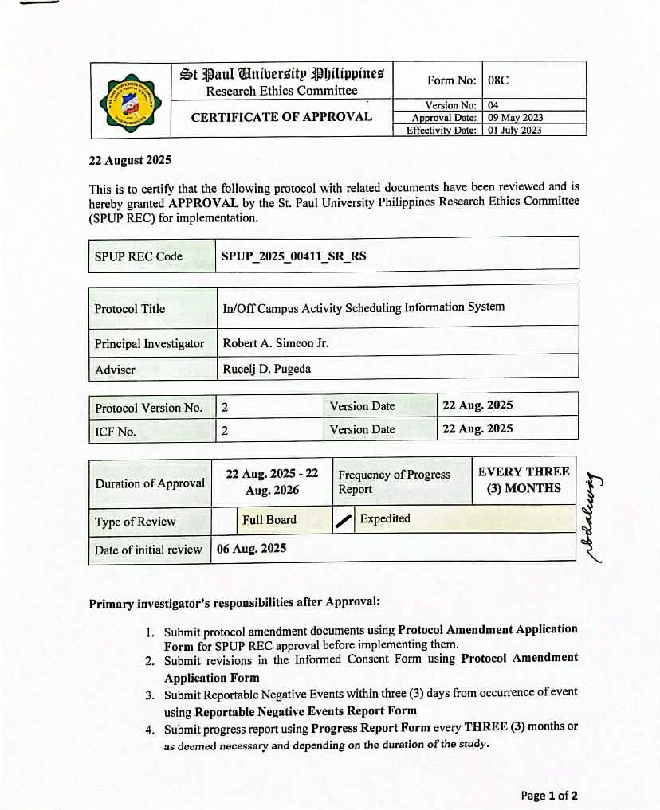
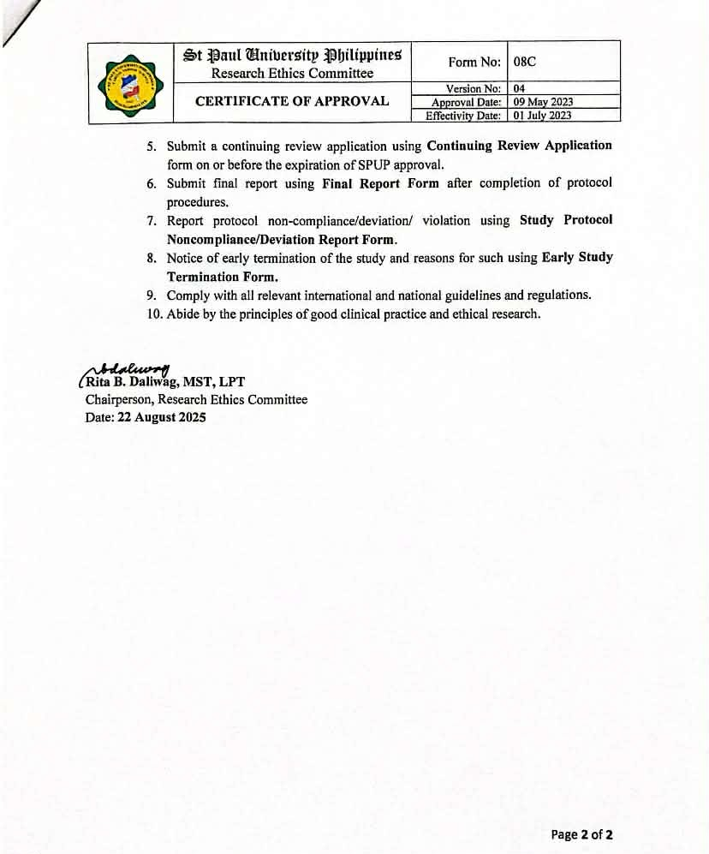

APPENDIX C
Endorsement Letter

APPENDIX D
Letter of Acceptance

APPENDIX E
Questionnaire for IT Experts
Instructions: Please indicate your assessment as to the compliance of the system to the ISO/IEC 25010:2011 requirements and its relevance in terms of the system’s efficiency, usability, reliability, functionality. Please check the corresponding column that best represents your response using the following scales:
5 – Very Great Extent 4 – Great Extent 3 – Moderate Extent 2 – Low Extent 1 – Very Low Extent
(PART I) Quality Criteria of System based on ISO/IEC 25010:2011
Attributes | Level of Agreement
- Functional Suitability | 5 | 4 | 3 | 2 | 1
a.1 Functional completeness. The system covers all the specified tasks and user objectives.
a.2 Functional correctness. The system provides the correct results with the needed degree of precision.
a.3 Functional appropriateness. The system facilitates the accomplishment of specific tasks, and objectives.
- Performance Efficiency | 5 | 4 | 3 | 2 | 1
b.1 Time Behavior. The system’s response and processing times and throughput rates when performing its functions, meet requirements.
b.2 Resource Utilization. The system’s amounts and types of resources used when performing its functions, meet requirements.
b.3 Capacity. The system’s maximum limits of parameter meet requirements.
- Compatibility | 5 | 4 | 3 | 2 | 1
c.1 Co-existence. The system can perform its required functions efficiently while sharing a common environment and resources with other products, without detrimental impact on any other product.
c.2 Interoperability. The system can exchange information and use the information that has been exchanged.
- Usability | 5 | 4 | 3 | 2 | 1
d.1 Appropriateness Recognizability. The system allows users to recognize if it is appropriate for their needs.
d.2 Learnability. The system can be used by specified users to achieve specified goals of learning to use the application with effectiveness, efficiency, freedom from risk and satisfaction in a specified context of use.
d.3 Operability. The system has attributes that make it easy to operate and control.
d.4 User Error Protection. The system protects users against making errors.
d.5 User Interface Aesthetics. The system’s user interface enables pleasing and satisfying interaction for the user.
d.6 Accessibility. The system can be used by people with the widest range of characteristics and capabilities to achieve a specified goal in a specified context of use.
- Reliability | 5 | 4 | 3 | 2 | 1
e.1 Maturity. The system meets the needs for reliability under normal operation.
e.2 Availability. The system is operational and accessible when required for use.
e.3 Fault tolerance. The system operates as intended despite the presence of hardware and software faults.
e.4 Recoverability. The system can recover the data directly affected and re-established the desired state.
- Security | 5 | 4 | 3 | 2 | 1
f.1 Confidentiality. The system ensures that data are accessible only to those authorized to have access.
f.2 Integrity. The system is developed to prevent unauthorized access to, or modification of computer programs and data.
f.3 non-repudiation. The system’s event can be proven to have taken place and cannot be repudiated.
f.4 Accountability. The system’s action of an entity can be traced uniquely to the entity.
f.5 Authenticity. The systems identity of a subject or resource can be proved to be the one claimed.
- Maintainability | 5 | 4 | 3 | 2 | 1
g.1 Modularity. The system is composed of discrete components such that a change to one component has minimal impact on other components.
g.2 Reusability. The system’s asset can be used in more than one system, or in building other assets.
g.3 Analyzability. The system has the possibility to assess the impact on a product or system of an intended change to one or more of its parts, or to diagnose a product for deficiencies or causes of failures, or to identify parts to be modified.
g.4 Modifiability. The system can be effectively and efficiently modified without introducing defects or degrading existing product quality.
g.5 Testability. The system can establish test criteria and test can be performed to determine whether those criteria have been met.
- Portability | 5 | 4 | 3 | 2 | 1
h.1 Adaptability. The system can effectively and efficiently be adapted for different or evolving hardware, software or other operational or usage environments.
h.2 Installability. The system can be successfully installed and/or uninstalled in a specified environment.
h.3 Replaceability. The system can replace another specified software

APPENDIX F
Curriculum Vitae


Robert A. Simeon Jr.

PERSONAL DATA
Birthdate : 07, 06, 2004
Birthplace : Santo Niño, Cagayan
Gender : Male
Civil Status : Single
Citizenship : Filipino
Religion : Roman Catholic
Home Address : Municipal st. Centro Norte Santo Niño, Cagayan
Contact No. : +639215512415
E-mail Account : robertsimeon12345@gmail.com

EDUCATIONAL BACKGROUND
Bachelor’s Degree : Bachelor of Science in Information Technology, St. Paul University Philippines, 2022- Present
Senior High School : St. Paul University Philippines, 2020-2022
Junior High School : Santo Niño National High School, 2016-2020

CERTIFICATIONS:
  - Information Technology Specialist in HTML and CSS
  - Certificate of Participation, ITE CONVENTION 2024
  - Certificate of Participation, The Art of Filmmaking Workshop 2024



Louise Anthony S. Bugayong

PERSONAL DATA
Birthdate : 01, 30, 2004
Birthplace : Tuguegarao City, Cagayan
Gender : Male
Civil Status : Single
Citizenship : Filipino
Religion : Roman Catholic
Home Address : 618 D. Tumaliuan St. Tramo Road Atulayan Norte Tuguegarao City , Cagayan
Contact No. : +639157643805
E-mail Account : louiseanthonybugayong3@gmail.com

EDUCATIONAL BACKGROUND
Bachelor’s Degree : Bachelor of Science in Information Technology, St. Paul University Philippines, 2022- Present
Senior High School: St. Paul University Philippines, 2020-2022
Junior High School: St. Paul University Philippines, 2016-2020

CERTIFICATIONS:
  - Information Technology Specialist in HTML and CSS
  - Certificate of Participation, ITE CONVENTION 2024
  - Certificate of Participation, The Art of Filmmaking Workshop 2024

APPENDIX G
Documentation
